|  |
| --- |
| User Guide |
| California Public Utilities Commission  RPS Database |
| March 2025 v2.01 |
| This User Guide provides users with instructions to navigate and submit Monthly, Semi-Annual PCIA, Offer, and Compliance Reporting, as well as Procurement Plans, Contract Documents, and Shapefiles through the CPUC Renewables Portfolio Standard (RPS) Database. |

Contents

RPS Database Introduction & Access 1

Background 1

User Roles 1

Data Submission 2

Accessing the RPSD Database for the First Time 4

Procedure: New Organization Sign Up 4

Procedure: New User Sign Up 9

Two-Factor Authentication (2FA) 17

Procedure: 2FA Setup (Android MS Authenticator) 17

Logging In and Out of the RPS Database 20

Change Password 23

Dashboard Functionality 26

Dashboard 26

Calendar 27

Tasks 28

Support Tickets 29

Data Dictionary 30

General Help & FAQ 34

Creating a New Data Submission 36

Procedure: Creating a New Data Submission 36

Error Handling in Data Submissions 42

Procedure: Data File Error Correction 42

Submission Queries 44

Projects Functionality 45

Project Search 45

Working with Projects 47

Procedure: Uploading a Project Shape File 48

Figures

Figure 1: RPSD Database Sign In Page 4

Figure 2: View the CPUC Site Terms and Conditions 4

Figure 3: Accept Terms and Create a New Account 5

Figure 4: The Email Confirmation and RE-SEND Code Screen 6

Figure 5: Confirmation Code Email 6

Figure 6: Entering the Confirmation Code 7

Figure 7: Account Pending Approval Screen 7

Figure 8: Account Confirmation Email 8

Figure 9: RPSD Database Sign In Page 9

Figure 10: Selecting an Organization from the New User Sign Up Details Screen 10

Figure 11: User Details Entered 10

Figure 12: View the CPUC Site Terms and Conditions 11

Figure 13: Accept Terms and Create a New Account 11

Figure 14: The Email Confirmation and RE-SEND Code Screen 12

Figure 15: Confirmation Code Email 12

Figure 16: Entering the Confirmation Code 13

Figure 17: Account Pending Approval Screen 13

Figure 18: Account Confirmation Email 14

Figure 19: Logging into the RPS Database 14

Figure 20: The Two Factor Authentication (2FA) Page with QR Code 15

Figure 21: The PRS Ddatabase Invite Your Team Page 15

Figure 22: Sending Database Enrollment Invitations to Your Team 16

Figure 23: The RPS Database Welcome Page 16

Figure 24: Microsoft Authenticator Launch Screen (Android shown) 17

Figure 25: Adding a Work or School Account to Authenticator 17

Figure 26: Selecting the QR Code Registration Option 18

Figure 27: Sample Database 2FA QR Code 18

*Figure 28: Scanning the Registration QR Code* 18

*Figure 29: Confirming App Lock Enabled* 18

*Figure 30: RPS Database 2FA Account in Authenticator* 19

Figure 31: RPSD Database Login Page 20

Figure 32: System Prompt for Your 2FA Code 20

Figure 33: 2FA Code Displayed in Authenticator 21

Figure 34: Enter Your 2FA Code from Authenticator 21

Figure 35: The Logout Action from the My Account Menu 22

Figure 36: Initiating a Request to Remedy a Forgotten Password 23

Figure 37: Specifying the Email Address for a Password Reset 23

Figure 38: Sample Email Password Reset Confirmation Code 24

Figure 39: Entering a Password Reset Code 24

Figure 40: Entering a New Password 25

Figure 41: Entering a 2FA Code 25

Figure 42: The CPUC-Dashboard 26

Figure 43: The Notifications Pop Out 26

Figure 44: The Dashboard Calandar 27

Figure 45: Sample Calendar Event Window 27

Figure 46: The Dashboard My Tasks Area 28

Figure 47: The New Task Pop Out 28

Figure 48: Opening a New Support Ticket 29

Figure 49: The New Support Ticket Dialog Box 29

Figure 50: Opening the Data Dictionary 30

Figure 51: Submissions Displayed from the Data Dictionary Function 30

Figure 52: Selecting a Submission Type 31

Figure 53: Accessing the Sort and the Filter Functions 31

Figure 54: Location Data View Options 32

Figure 55: Filter Options 32

Figure 56: The Search Field 33

Figure 57: Typical Report Data 33

Figure 58: Accessing General Help 34

Figure 59: Accessing Answers to FAQs 34

Figure 60: Sample FAQ Detail 35

Figure 61: Main Submissions Screen – Download Template Files 36

Figure 62: Selecting a New Submission Event 36

Figure 63: Select a New Submission WORKBOOK 37

Figure 64: Selecting a New Submission File Type for UPLOAD 37

Figure 65: Selecting Template Files by Submission Event 38

Figure 66: DOWNLOAD a Template File 38

Figure 67: Selecting Template Files by Submission Event 39

Figure 68: Database Uploading a Submissions File 39

Figure 69: Exiting the Upload Template Window 40

Figure 70: SUBMIT CHANGES FOR REVIEW Window 40

Figure 71: Upload Template Complete 41

Figure 72: Error Detected in File Window 42

Figure 73: DOWNLOAD ERROR FILE Window 42

Figure 74: RE-UPLOAD EXCEL FILE Window 43

Figure 75: Submission Query Window 44

Figure 76: The Projects Main Window 45

Figure 77: The Project Details Window 47

Figure 78: UPLOAD a Shape File 48

Figure 79: The Shape File Upload Window 48

Figure 80: Shape File Selected 49

Figure 81: Shape File Processing 49

Figure 82: Shape File Processing Failed Error Message 50

# RPS Database Introduction & Access

## Background

In August of 2024, the Renewables Portfolio Standard (RPS) team at the California Public Utilities Commission (CPUC) launched the new RPS Database. The database expanded upon the previous system that was available only to the large investor-owned utilities (IOUs). The RPS Database is now available to all CPUC RPS retail sellers, including the IOUs, small multijurisdictional utilities (SMJUs), community choice aggregators (CCAs), and electric service providers (ESPs).

CPUC RPS retail sellers will use the new RPS Database to submit all RPS-related data and reports.

The RPS Database can be accessed at: [**https://rpsd.cpuc.ca.gov**](https://rpsd.cpuc.ca.gov).

## User Roles

Your user role determines which database functions and areas you can access. Your Organizational Admin (or CPUC Admin) assigns your role when you initially register to access the database and can update it in the future as needed.

There are four tiers of user roles within the RPS Database. Everyone using the database is assigned a role depending on specific position activities and requirements. Roles are hierarchical and roles of a higher level have all the functionality and access as the roles below it.

#### Admin (Organizational):

* Can manage user roles, and review and approve new users for their organization. Can also do any other action for the roles below.

#### Attestor:

* Can **Attest** to data **Submissions** which is the final step in submitting them for approval by CPUC. Can also do any other action for the roles below.

#### Submitter:

* Can create and edit data **Submissions**. Can submit for **Attestation**, but cannot **Attest** themselves. Can also do any other action for the role below.

#### User:

* Can view **Dashboard**, data **Submissions**, and **Projects**, and create **Tasks** and **Support Tickets**.

## Data Submission

Organizations are required to submit reporting data to the CPUC to demonstrate compliance with the state's RPS program. RPS mandates a certain percentage of electricity sold by retail sellers must come from renewable energy sources, and the reporting details how much renewable energy an organization has procured to meet the RPS standards.

Data will be submitted to the RPS Database using CPUC-predefined Excel file templates. Apart from Excel files, narrative documents, contract documents, and geographical shapefiles that denote RPS project sites may also be submitted through the system.

Table 1: Data Submissionsbelow identifies the full list of data submission types, what types of organization may need to submit, and what data files may be included. Due dates are as below in Table 1, unless otherwise communicated to retail sellers by the CPUC.

Please note that the CPUC may require additional reporting to be submitted into the RPS Database in the future.

Table : Data Submissions

| Num | Data Submission | Files | Retail Sellers | Due Date |
| --- | --- | --- | --- | --- |
| 1 | Monthly Report | * Monthly Submittal File of Executed RPS Projects * Confidentiality Declaration * Attestation | IOUs (PG&E, SCE, and SDG&E) | 15th monthly, except in months when a Semi-Annual PCIA Report is due |
| 2 | Semi-Annual PCIA Report | * Semi-Annual Submittal File of Executed RPS Projects * GHG Free Data Request * Confidentiality Declaration * Attestation | All | Sept. 1 and February 1 annually |
| 3 | Offer Report | * RPS Offers against an active RPS Solicitation * Confidentiality Declaration * Attestation | IOUs (PG&E, SCE, and SDG&E) | Ad-hoc |
| 4 | Procurement Plan | * Renewables Net Short (RNS) * Cost Quantifications * Project Development Status Update/Report * SB 1174 Data Report * Procurement Plan Narrative * Procurement Plan Narrative - redacted * Confidentiality Declaration * Attestation | All | July 1 annually for draft plan, and as communicated by the CPUC for final plans |
| 5 | Compliance Report | * Compliance Report (SMJU specific or IOU/CCA/ESP version) * e-Tag Summary Report * Hourly Meter and e-Tag reconciliation Report * Compliance Report Narrative * Compliance Report Narrative - redacted * Contract documents related to RECs purchased or sold * Confidentiality Declaration * Attestation | All | August 1 annually |
| 6 | Contract Documents | * Contract documents may be uploaded for a chosen RPS Project * Confidentiality Declaration * Attestation | All | Ad-Hoc |
| 7 | Shapefile | * Shapefiles may be uploaded for a RPS project * Confidentiality Declaration * Attestation | IOUs (required) and SMJU/CCA/ESP (optional) | Ad-Hoc |

## Accessing the RPSD Database for the First Time

### Organization Registration

RPS retail sellers must register their organization with the CPUC before any of its users can access and use the database.

Procedure: New Organization Sign Up

1. Begin by browsing to the RPS Database registration page at <https://rpsd.cpuc.ca.gov>. Click Sign up to proceed.

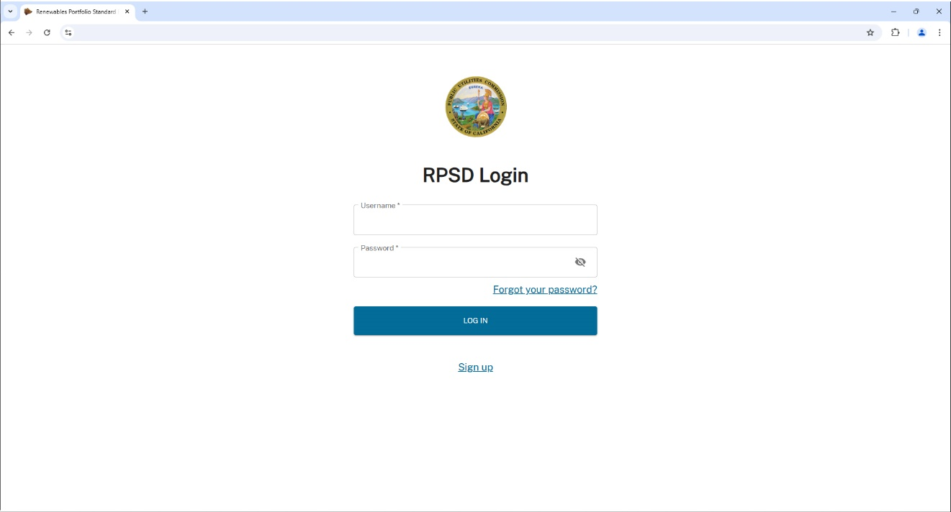

Figure 1: RPSD Database Sign In Page

1. Click the Terms and Conditions link to view the site **Condition of Use**, which will open in a new browser tab. Once you have reviewed the terms, close the browser tab.

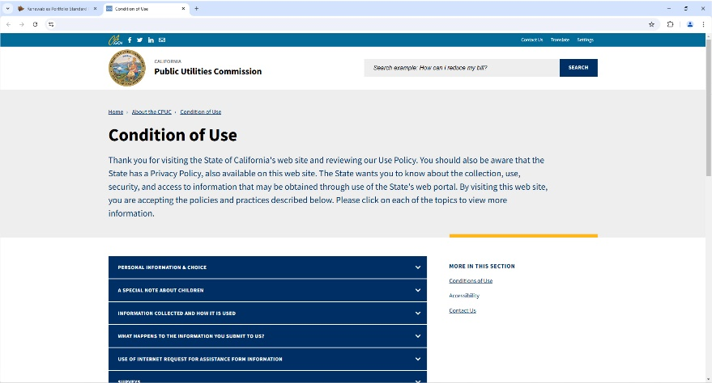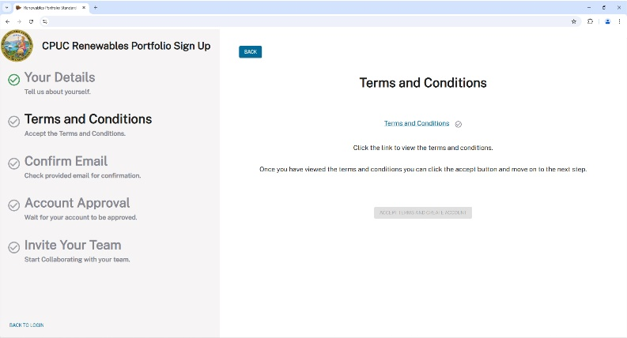

Figure 2: View the CPUC Site Terms and Conditions

1. Click the ACCEPT TERMS AND CREATE ACCOUNT button to submit your account information.

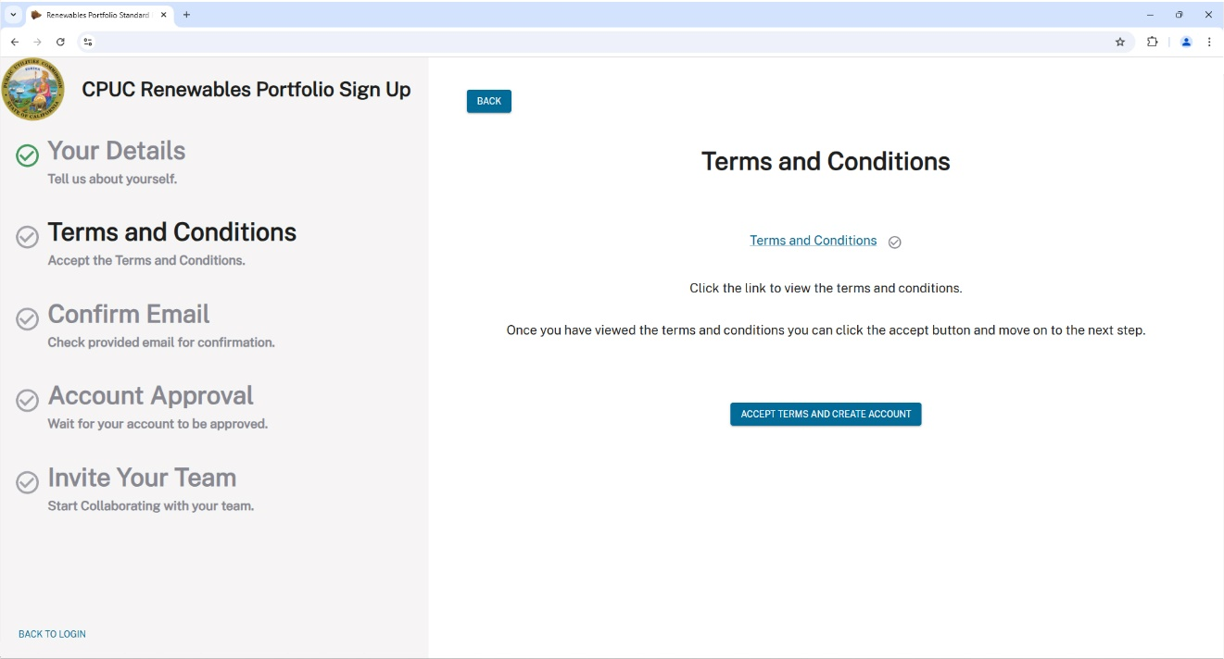

Figure 3: Accept Terms and Create a New Account

Note: you can click the BACK button to review previous pages before submitting your new Organization account information.

1. The database will advance to the **Email Confirmation** screen. You will receive a Confirmation Code email from [noreply_rpsd_email@cpuc.ca.gov](mailto:noreply_rpsd_email@cpuc.ca.gov) at the address you provided.

Note: If you do not receive a code, first check your SPAM/JUNK email folder. If a Confirmation email is not present, click the RE-SEND button to request another code.

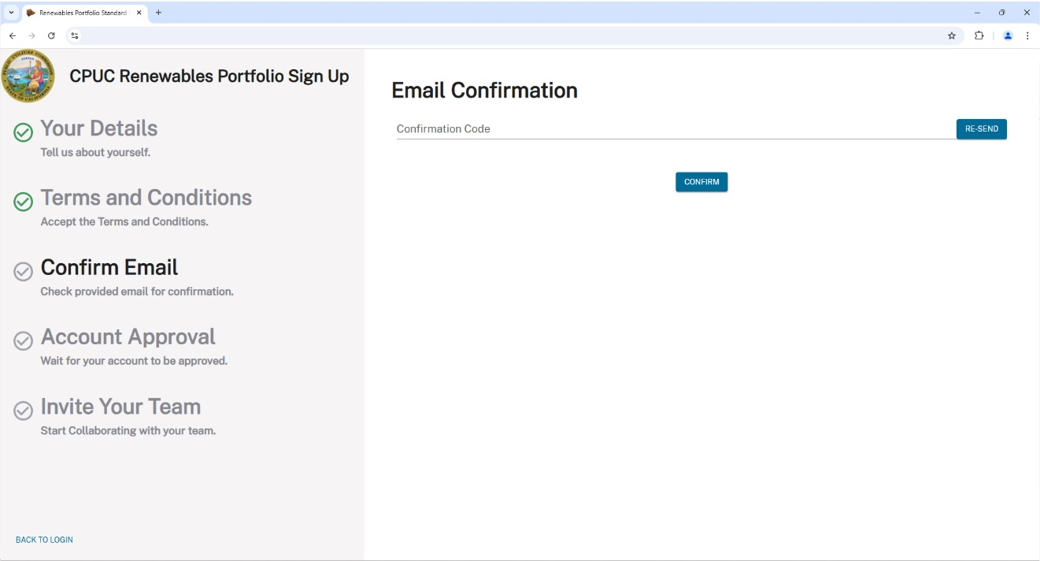

Figure 4: The Email Confirmation and RE-SEND Code Screen

Note: contact the CPUC RPS admin for assistance if you do not receive a Confirmation Email.

1. Copy the **Confirmation Code** from the email.

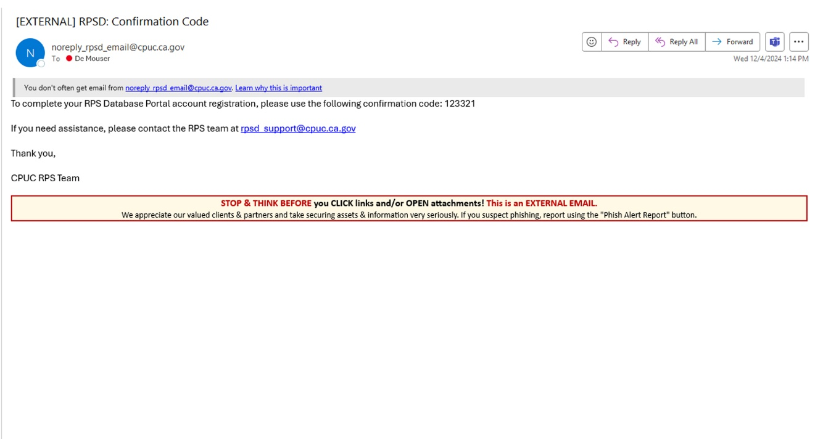

Figure 5: Confirmation Code Email

1. Paste the code in the **Email Confirmation** field, then click CONFIRM to proceed to the **Account Pending Approval** screen shown in Figure 7.

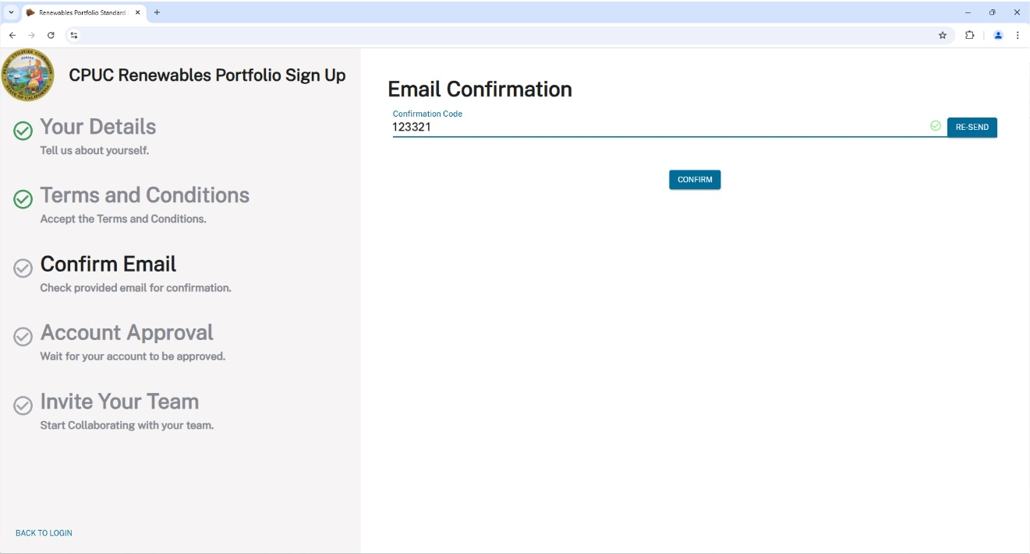

➋

➊

Figure 6: Entering the Confirmation Code

Your account is now awaiting registration approval. You will receive another email from [**noreply_rpsd_email@cpuc.ca.gov**](mailto:noreply_rpsd_email@cpuc.ca.gov) stating that your RPS Database account has been confirmed (as shown in Figure 8).

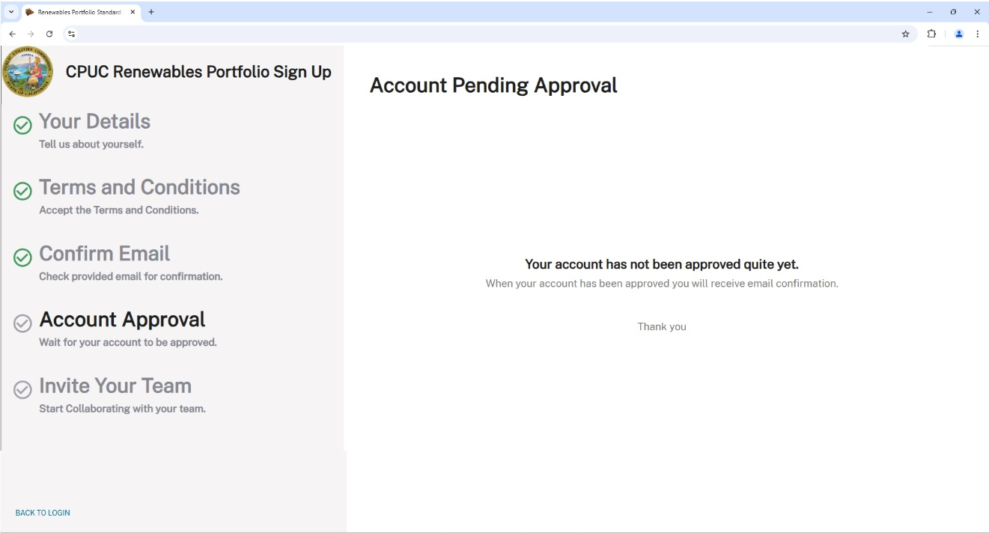

Figure 7: Account Pending Approval Screen

1. The email from [**noreply_rpsd_email@cpuc.ca.gov**](mailto:noreply_rpsd_email@cpuc.ca.gov) verifies your RPS Database account is confirmed and provides a link back to the database login screen. Click the RPSD Database link to login and use the database.

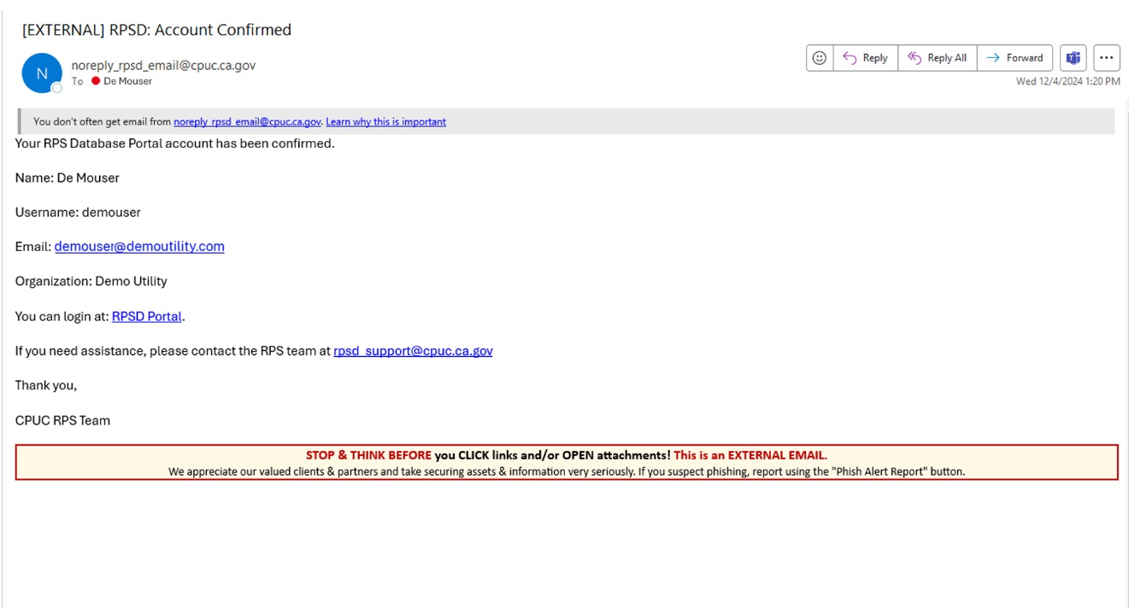

Figure 8: Account Confirmation Email

### User Registration

All new users must complete the registration process before they can access and use the database.

Note: If you are the Organization’s Administrator, your initial login from the Account Confirmation Email shown in Figure 8 will take you directly to the Login screen shown in Figure 19: Logging into the RPS because your initial account registration is already complete.

Procedure: New User Sign Up

1. Begin by browsing to the RPS Database registration page at [**https://rpsd.cpuc.ca.gov**](https://rpsd.cpuc.ca.gov). Click Sign up to proceed.



Figure 9: RPSD Database Sign In Page

Note: an Admin from your organization can also invite you to join the RPS Database. If an invitation is initiated, you will receive an email message from **noreply_rpsd_email@cpuc.ca.gov** with a sign-up link. Click that link to take you directly to the **Sign Up** page shown in Figure 10.

1. Select your **Organization** from the drop-down list.

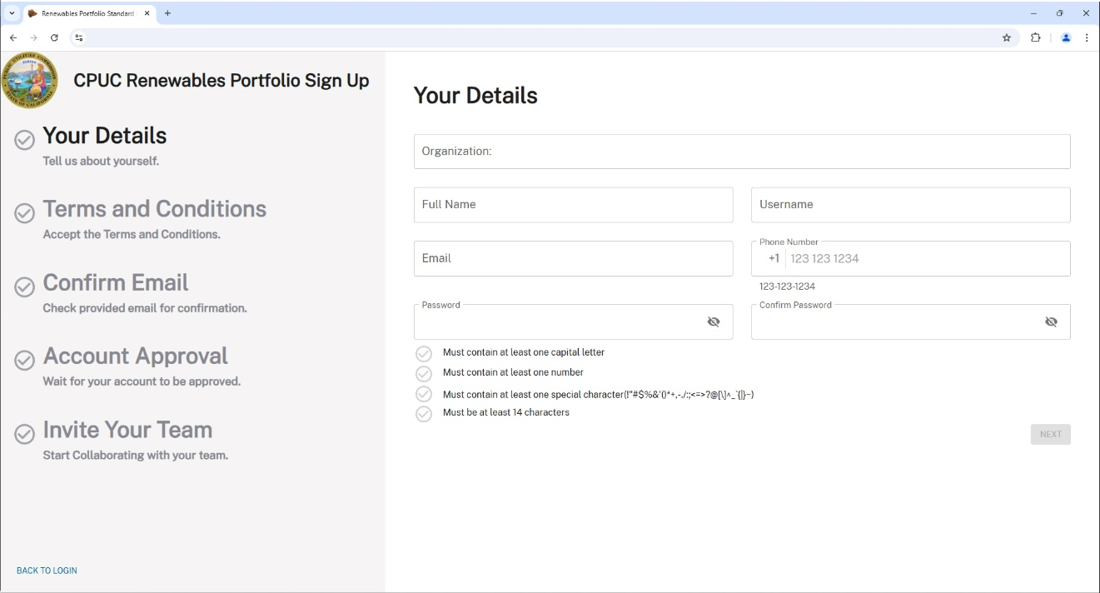

Figure 10: Selecting an Organization from the New User Sign Up Details Screen

1. Enter your new account information: **Full Name, Username, Email, Phone Number, and Password** (ensuring your selected password meets the listed CPUC password requirements.) Confirm your password by reentering it a second time. Click the NEXT button (enabled after you enter your information) to proceed.

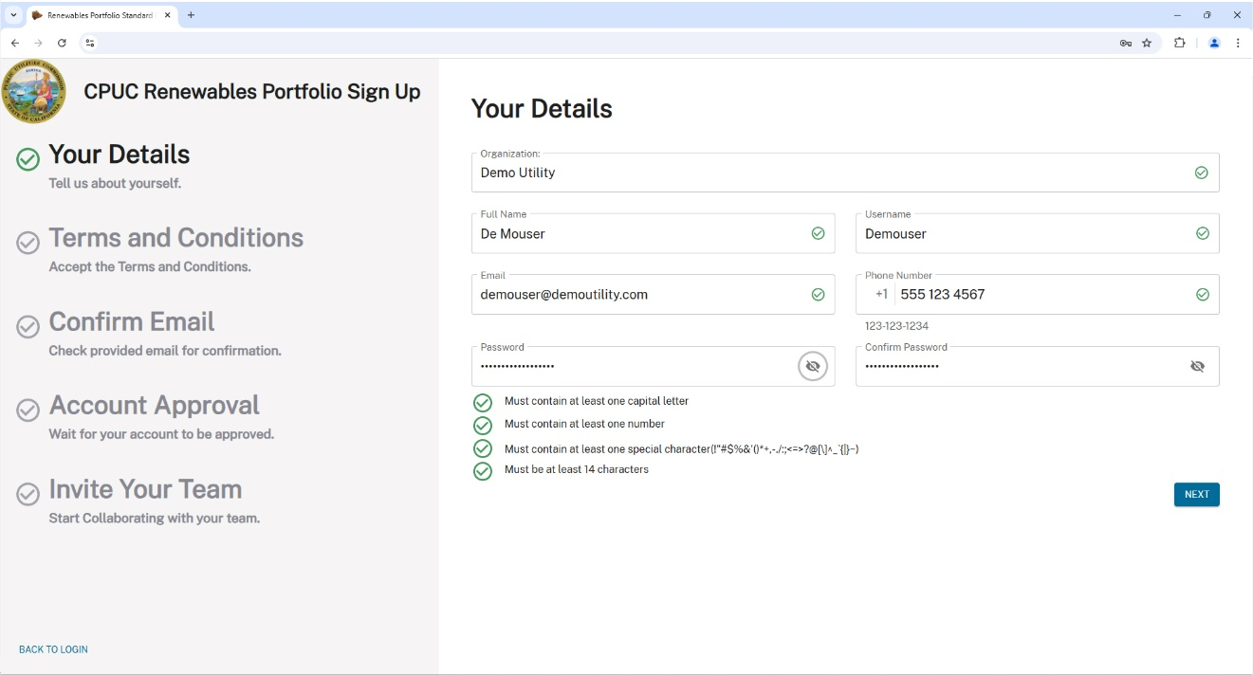

➊

➋

Figure 11: User Details Entered

Note: individuals representing multiple retail sellers, submitting data on their behalf, must create separate user accounts for each organization. One email address may be used for multiple user accounts, but unique **Usernames** must be created.

1. Click the Terms and Conditions link to view the site **Condition of Use information**, which will open in a new browser tab. Then close the browser tab to continue.



➋

➊

Figure 12: View the CPUC Site Terms and Conditions

1. Click the ACCEPT TERMS AND CREATE ACCOUNT button to submit your account information.



Figure 13: Accept Terms and Create a New Account

Note: you can click the BACK button to review previous pages before submitting your new account information.

1. The database will advance to the **Email Confirmation** screen. You will receive a **Confirmation Code** email from noreply_rpsd_email@cpuc.ca.govsend at the email address you provided in Figure 11.

If you do not receive a code, first check your SPAM/JUNK email folder. If a Confirmation email is not present, click the RE-SEND button to request another code.



Figure 14: The Email Confirmation and RE-SEND Code Screen

Note: contact your Organization’s CPUC RPS admin for assistance if you do not receive a Confirmation Email.

1. Copy the **Confirmation Code** from the email.



Figure 15: Confirmation Code Email

1. Paste the code in the **Email Confirmation** field. Click CONFIRM to proceed to the **Account Pending Approval** screen shown in Figure 17.



➋

➊

Figure 16: Entering the Confirmation Code

Your account is now awaiting registration approval. You will receive another email from [**noreply_rpsd_email@cpuc.ca.gov**](mailto:noreply_rpsd_email@cpuc.ca.gov) stating your RPS Database Database account has been confirmed (as shown in Figure 18).



Figure 17: Account Pending Approval Screen

1. The email from [noreply_rpsd_email@cpuc.ca.gov](mailto:noreply_rpsd_email@cpuc.ca.gov) verifies your RPS Database account is confirmed and provides a link back to the database login screen. Click the RPSD Database link to login and use the database.



Figure 18: Account Confirmation Email

1. Enter your **Username** and **Password**, then click the LOGIN button to log in and use the database.

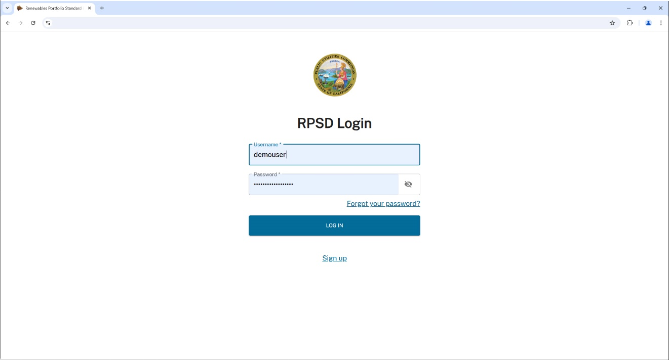

➋

➊

Figure 19: Logging into the RPS Database

You’ll be prompted to set up a two-factor authentication (2FA) method once your account is approved and you first access the database. This page appears at login until a 2FA method is set. You can skip the 2FA setup by clicking the SKIP button to advance to the **Invite Your Team** page (Figure 21).

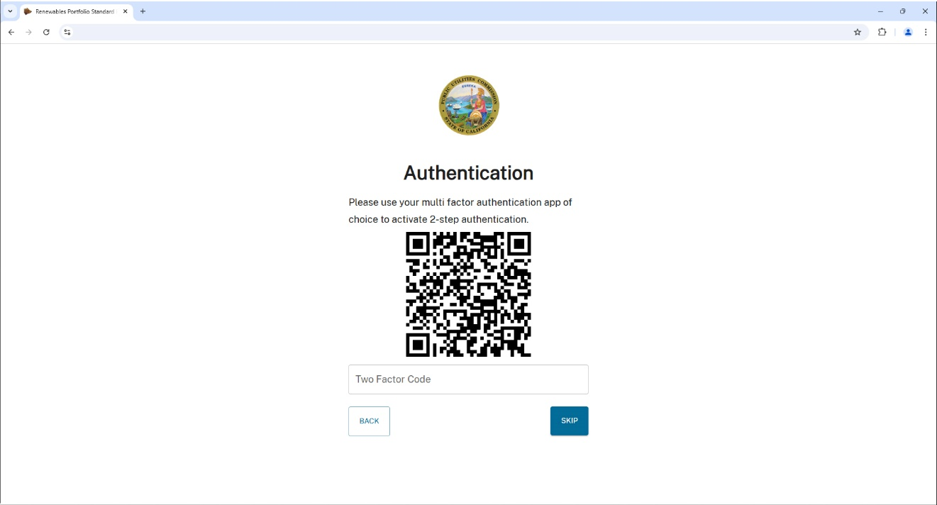

Figure 20: The Two Factor Authentication (2FA) Page with QR Code

Note: all users are strongly urged to enable 2FA as a security best practice.

You can send invitations to teammates or click SKIP to continue to the **Welcome** page shown in Figure 25.

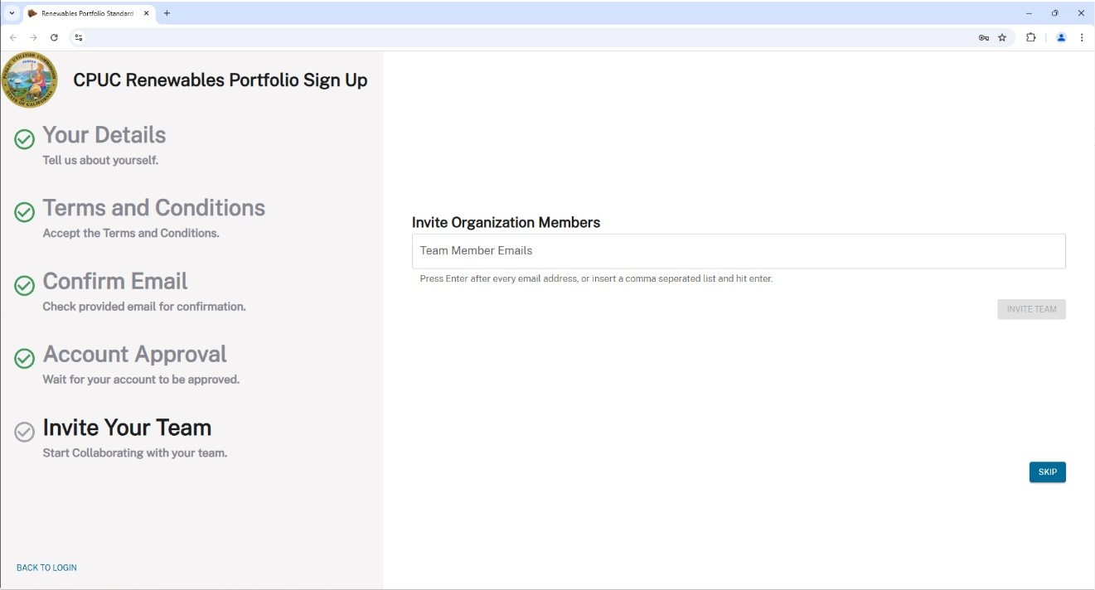

Figure 21: The PRS Ddatabase Invite Your Team Page

Send invitations to your team by entering an email address and then pressing ENTER on your keyboard after typing in each address. This activates the INVITE TEAM button. Click INVITE TEAM when done to send out the invitations.

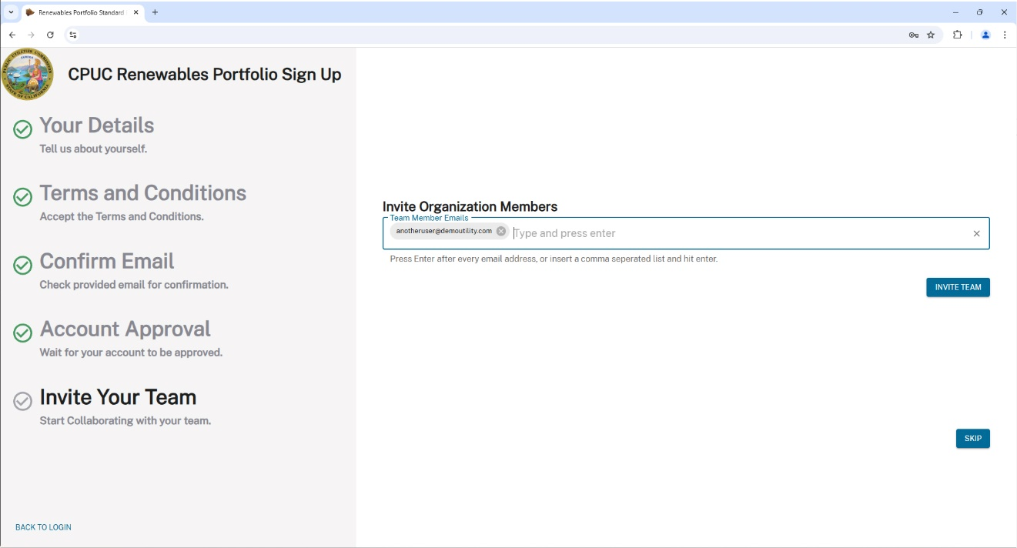

➋

➊

Figure 22: Sending Database Enrollment Invitations to Your Team

The RPS Database **Welcome** page confirms your sign up process is complete. Click ENTER RPSD WEB PORTAL to proceed.

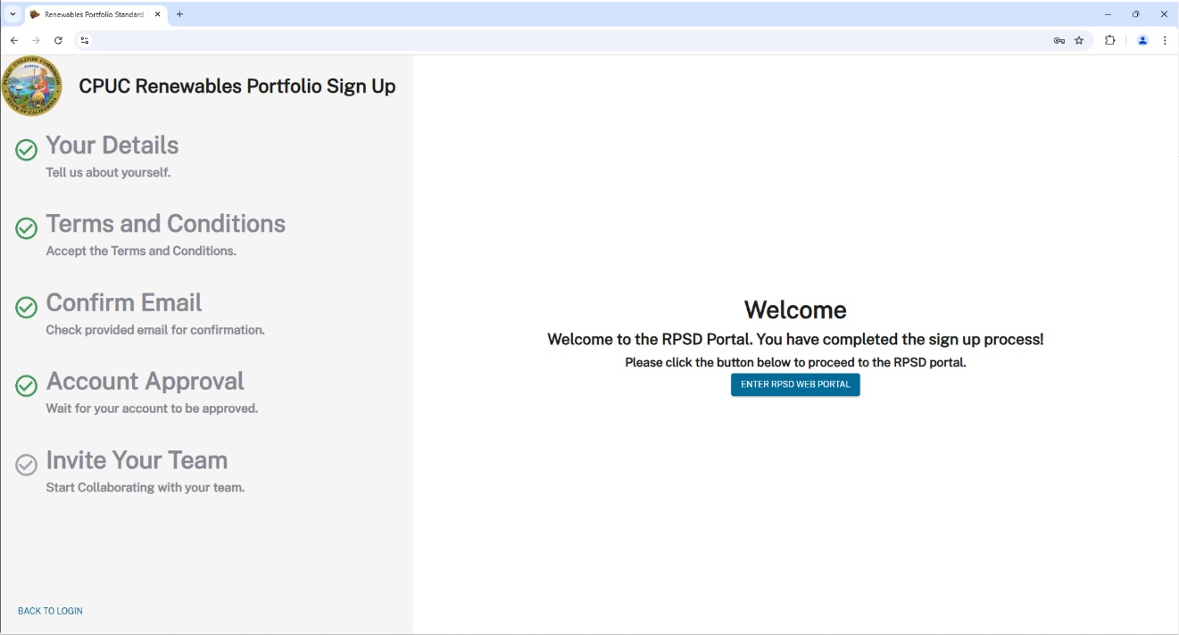

Figure 23: The RPS Database Welcome Page

## Two-Factor Authentication (2FA)

Two-factor authentication (2FA) or multi-factor authentication (MFA), is a security process where a user is only granted access to a website or app after successfully providing two or more verification factors. These factors typically consist of something the user knows (like a password), something the user has (like a mobile device), or something the user is (such as biometric data). 2FA enhances security by safeguarding information against unauthorized access, even if a single password is compromised.

There are several mobile apps you can use to fulfill the database 2FA requirement such as Microsoft (MS) Authenticator, Google Authenticator, or Apple Authenticator. The following sequence is demonstrated via the Android platform – the Apple procedure is similar.

Note: all users are strongly urged to enable 2FA as a security best practice.

Procedure: 2FA Setup (Android MS Authenticator)

|  |  |
| --- | --- |
| 1. The first time you open Authenticator, you will be presented with the screen shown below. Tap the Add account button to continue.   A screen shot of a phone  Description automatically generated  Figure 24: Microsoft Authenticator Launch Screen (Android shown) | 1. At the **Add account** screen, tap the Work or school account option to proceed.     Figure 25: Adding a Work or School Account to Authenticator |

|  |  |
| --- | --- |
| 1. When prompted how to create your two-step verification account, select Scan a QR code.     Figure 26: Selecting the QR Code Registration Option | 1. When you choose to set up 2FA at login, the system displays a QR Code for you to activate your 2FA app.     Figure 27: Sample Database 2FA QR Code |
| 1. Center the QR Code in the scanning window. The app will automatically capture and register the QR Code and advance to the next screen.     *Figure 28: Scanning the Registration QR Code* | 1. Tap OK to dismiss the App Lock enabled prompt.     *Figure 29: Confirming App Lock Enabled* |
| 1. 2FA code generation for secure access to the Renewables Portfolio Standard Database is now enabled.     *Figure 30: RPS Database 2FA Account in Authenticator* |  |

## Logging In and Out of the RPS Database

Access the RPS Database at <https://rpsd.cpuc.ca.gov>. Enter your **Username** and **Password**, then click LOG IN.



➋

➊

Figure 31: RPSD Database Login Page

### Logging In Using 2FA

When 2FA is enabled the database requires a 6-digit code generated by your Authenticator App after verifying your **Username** and **Password**. Enter this code at the system prompt shown below to log in.

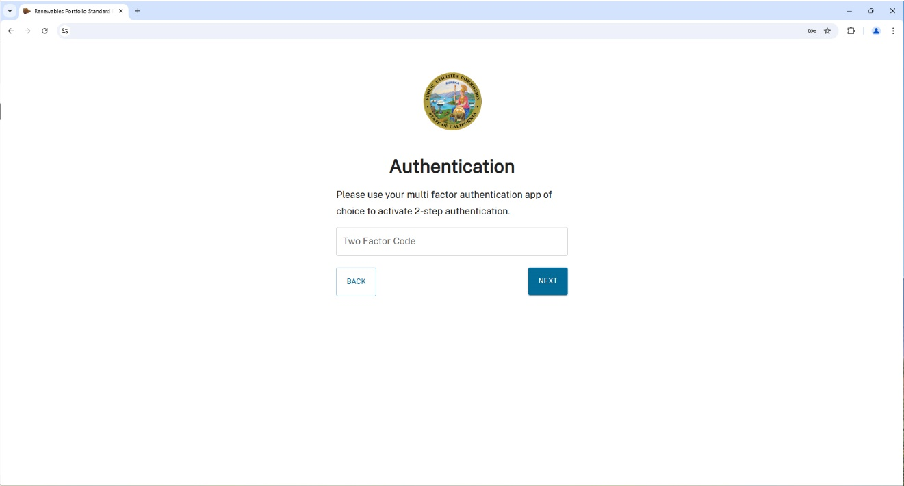

Figure 32: System Prompt for Your 2FA Code

Open your Authenticator app to access the authentication code (Android/MS Authenticator shown).

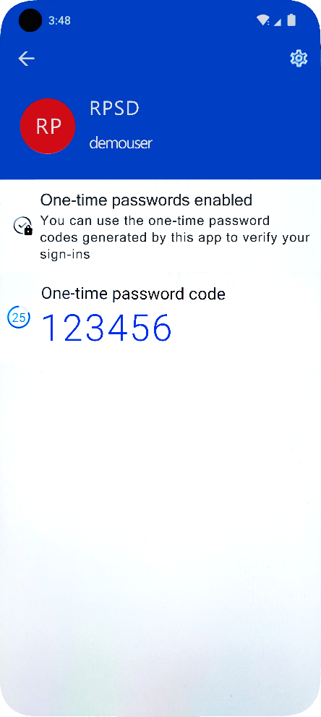

Figure 33: 2FA Code Displayed in Authenticator

Enter the 2FA Code from your Authenticator app and click the NEXT button to enter the RPS Database.

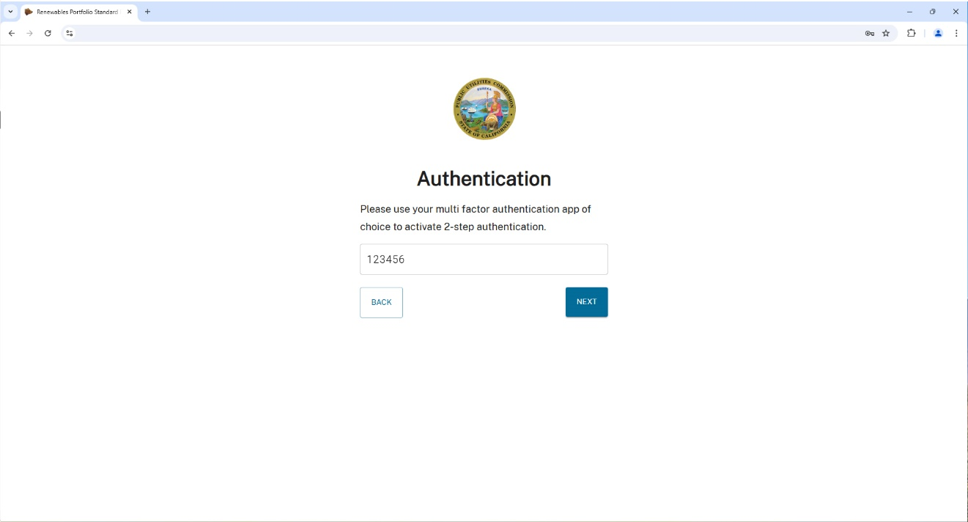

➋

➊

Figure 34: Enter Your 2FA Code from Authenticator

### How to Log Out

You should log out after completing work in RPS Database as a security best practice. Click the **My Account** icon  on the top right corner of the page and select Logout to properly exit the system.

Note: **Invite Members** and **Admin Settings** are only available to users with the Admin role.

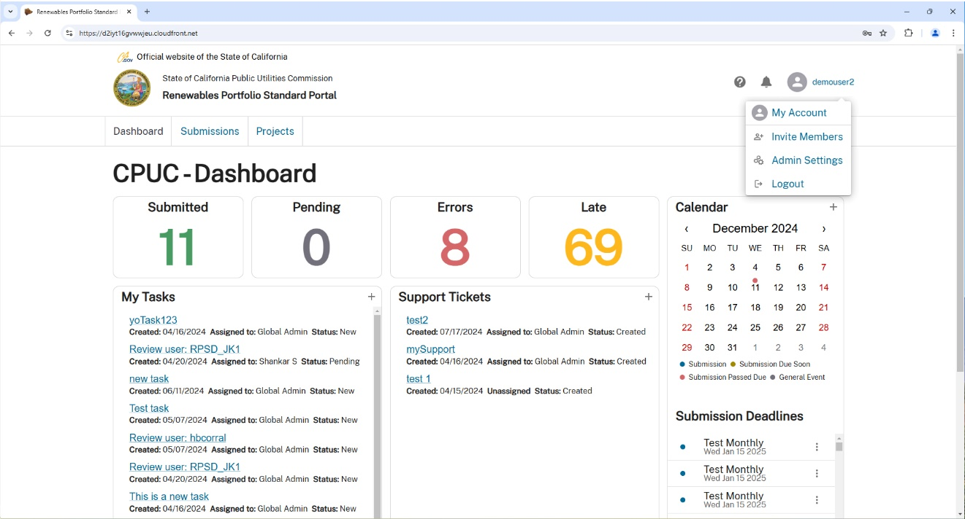

Figure 35: The Logout Action from the My Account Menu

## Change Password

CPUC security policies require you to change your RPS Database password every ninety (90) days, but you can change your password more often if you want to. If you forget your password, you can recover using the **Password Reset** function. Click on the Forgot your password? link on the RPS Database homepage at: <https://rpsd.cpuc.ca.gov>.



Figure 36: Initiating a Request to Remedy a Forgotten Password

Enter your **Username** and click SUBMIT. A reset code will be sent to the email address on file if the **Username** you provided is valid.

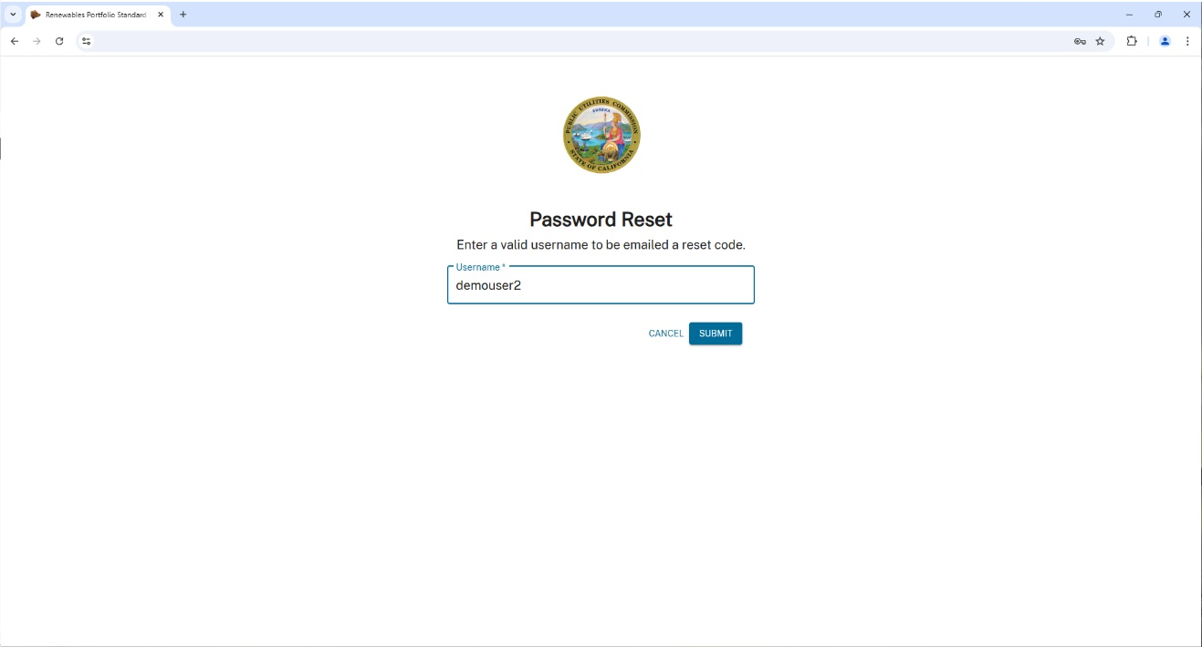

➋

➊

Figure 37: Specifying the Email Address for a Password Reset

Note: if you forget your **Username**, contact your organization’s Admin or the CPUC at [RPSD_Support@cpuc.ca.gov](mailto:RPSD_Support@cpuc.ca.gov).

Open the confirmation code email from the system (example shown below). The email will come from [noreply_rpsd_email@cpuc.ca.gov](mailto:noreply_rpsd_email@cpuc.ca.gov). Copy the code.

Note: if you cannot locate the **RPSD Account Confirmation** email, please check your Junk Mail or Spam folder.

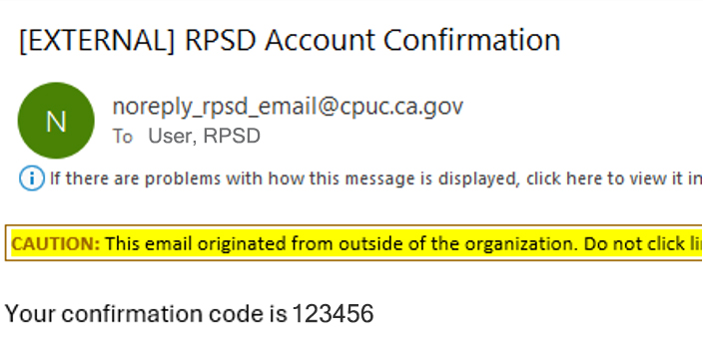

Figure 38: Sample Email Password Reset Confirmation Code

Enter (copy and paste) the code you received via email into the **Password Reset Code** field and click Next.

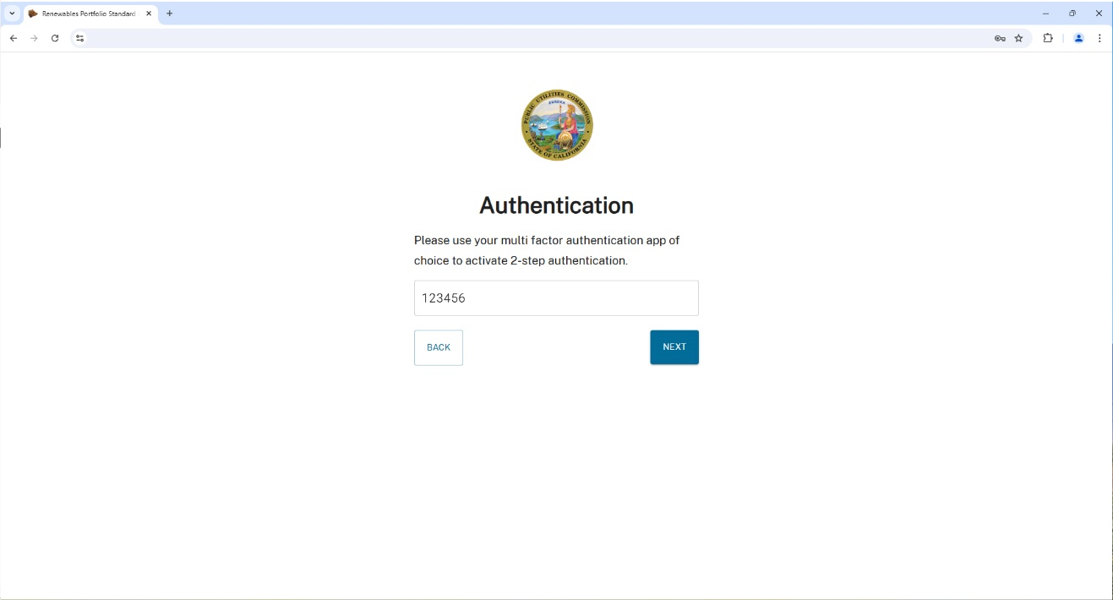

➊

➋

Figure 39: Entering a Password Reset Code

Enter your new Password, ensuring it conforms to the listed CPUC RPS requirements, then click the SUBMIT button.

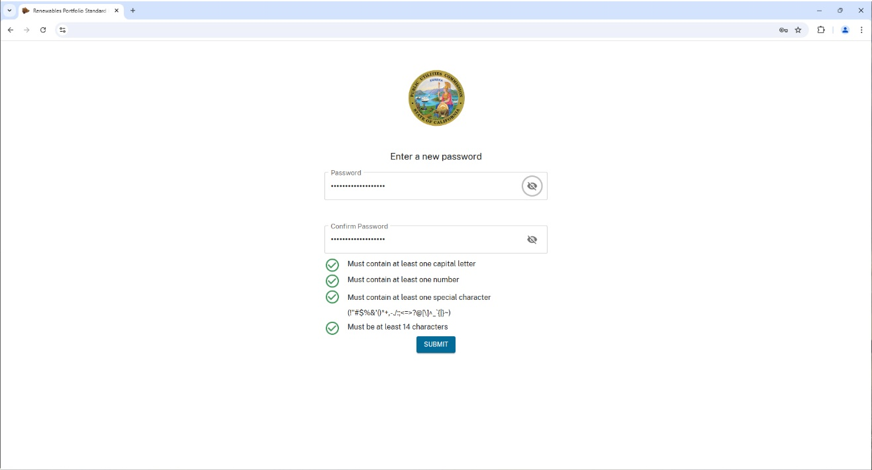

➊

➋

Figure 40: Entering a New Password

Access your Authenticator app, enter the current 2FA code, then click NEXT.

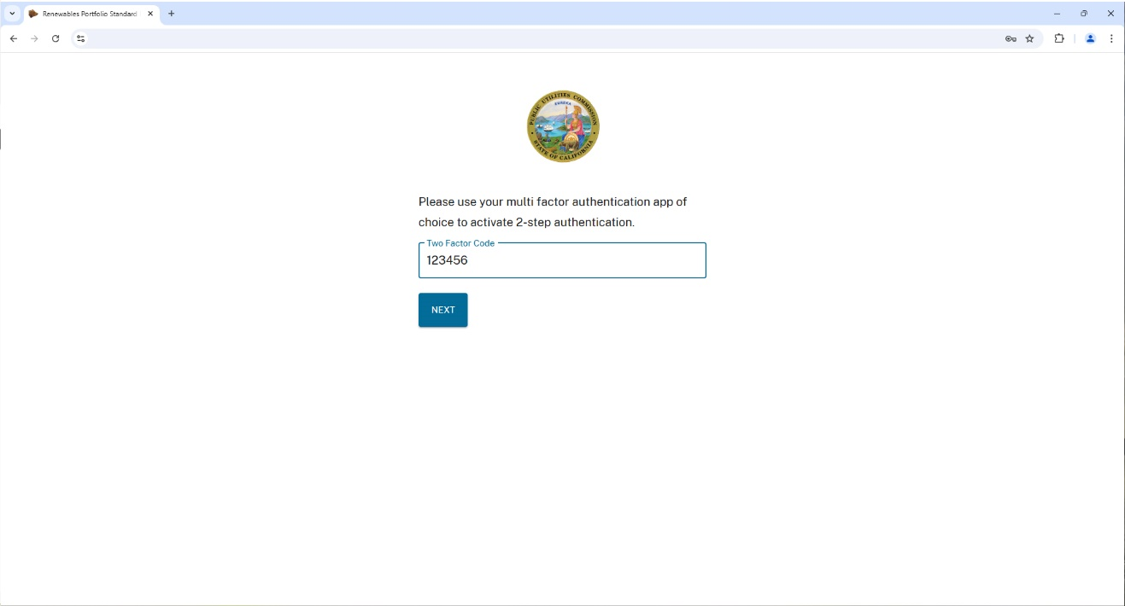

➋

➊

Figure 41: Entering a 2FA Code

# Dashboard Functionality

## Dashboard

The **CPUC - Dashboard** page is the main database page. The dashboard displays submission statistics (**Submitted**), pending activities (**Pending**), **Errors**, and **Late** items, along with your to-do’s (**My Tasks**) and submitted **Support Tickets**. There is also a calendar with Submission deadlines displayed. Any **Notifications** that require your attention can be accessed by clicking the bell  icon.

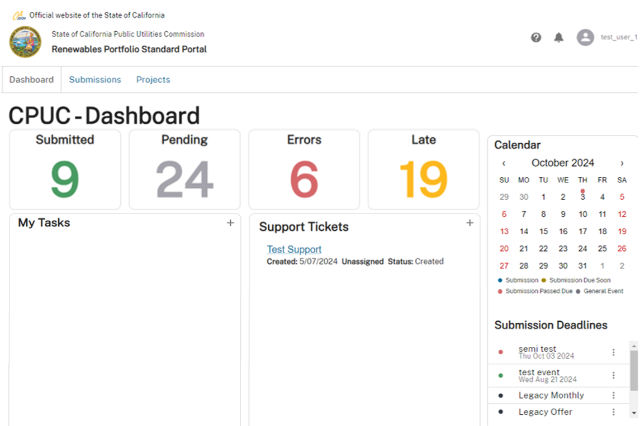

Figure 42: The CPUC-Dashboard

A pop out sidebar will display new **Notifications**. Click the  to close the **Notifications** pop out.

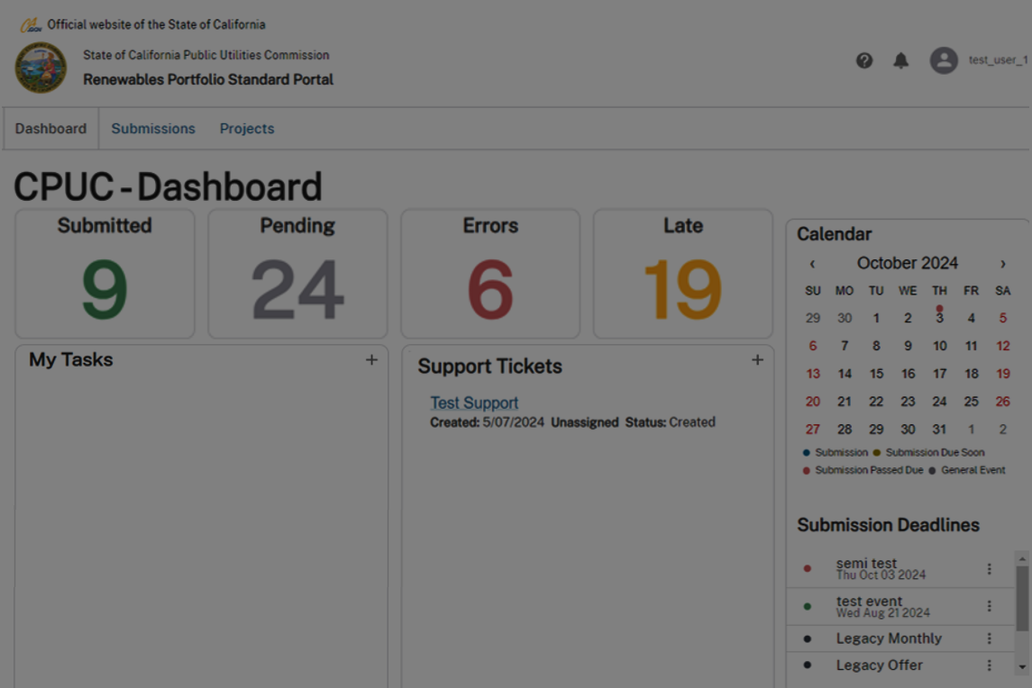

Figure 43: The Notifications Pop Out

## Calendar

The CPUC RPS team manages the RPS Database Submissions **Calendar**, located on the right-hand side of the dashboard page. The calendar specifies default **Submission Deadlines** by Submission type. These are also called **Submission Events**. Submission events are usually in the future except for late submissions. You can access the calendar to view calendar events and submission due dates. **Calendar** **Events** are color coded with dots. Details are presented in a pop out when you click on a date with a colored dot.



Figure 44: The Dashboard Calandar

Click the  to close the Events pop out.

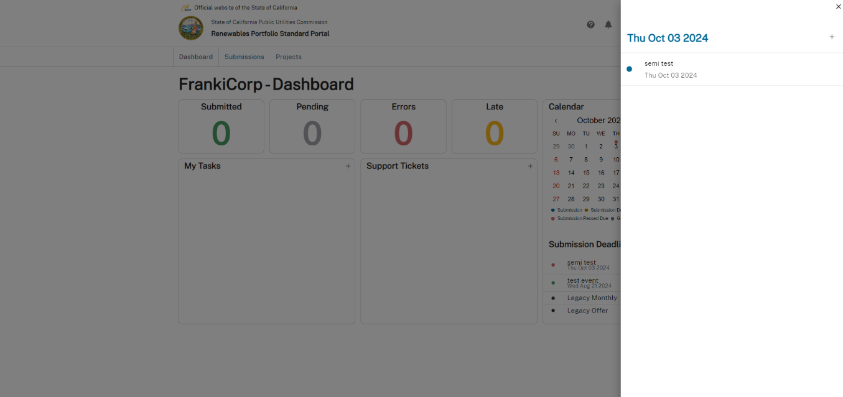

Figure 45: Sample Calendar Event Window

## Tasks

**Tasks** represent a unit of work performed or to be performed. You can create tasks and assign them to other users within your organization. The Dashboard has an option called **My Tasks**. Click the plus sign + in the My Tasks area to open a window to define a new task, shown below in Figure 47.



Figure 46: The Dashboard My Tasks Area

Enter your task information and click SAVE (now enabled) to submit the new Task. Exit without saving by clicking the  or the CANCEL button close the pop out.

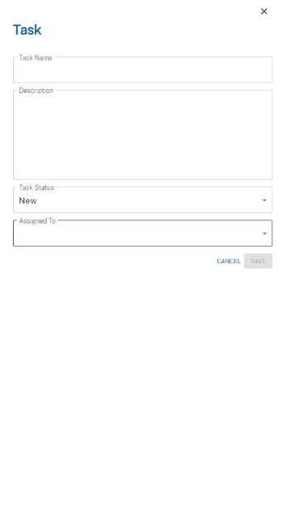

➋

➊

Figure 47: The New Task Pop Out

## Support Tickets

The RPS Database allows you to create **Support Tickets** to report system issues you encounter. Support tickets are monitored by the CPUC RPS Database Maintenance & Operations (M&O) team. They will take action to resolve issues noted in support tickets, update ticket statuses, and communicate updates to users.

Note: any existing tickets will be listed in the **Support Tickets** area of the Dashboard.

Support tickets are created in the **Dashboard** tab. Click the plus sign + in the **Support Tickets** section to create a new ticket. This will open a dialog box like the example shown in Figure 49.



Figure 48: Opening a New Support Ticket

Provide the required detail in the **Support Ticket** dialog box, then click the SAVE button (now enabled) to submit it, or exit without saving by clicking the  or the CANCEL button.

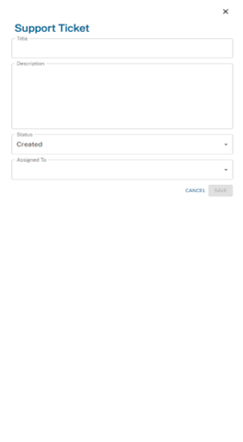

➋

➊

Figure 49: The New Support Ticket Dialog Box

## Data Dictionary

You can access the **Data Dictionary** by clicking the help button  in the upper right corner of the page, then click Data Dictionary from the pop out menu.

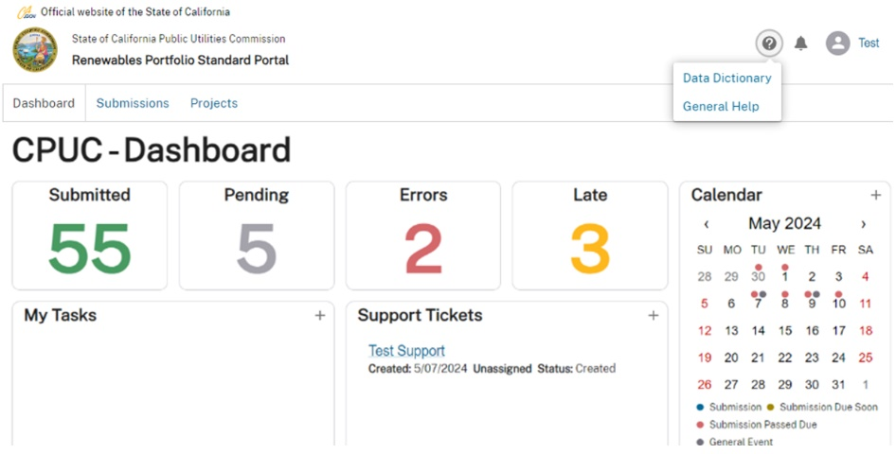

➊

➋

Figure 50: Opening the Data Dictionary

The Data Dictionary is organized by **Submission Type** and the default view is **Monthly Report**. The Submission Type information, arranged in columns, is shown in the typical example below.

Note: there are two scroll bars accessible from this view. The interior bar scrolls through the Submission detail, and the right-hand bar scrolls through any available Submission types displayed.

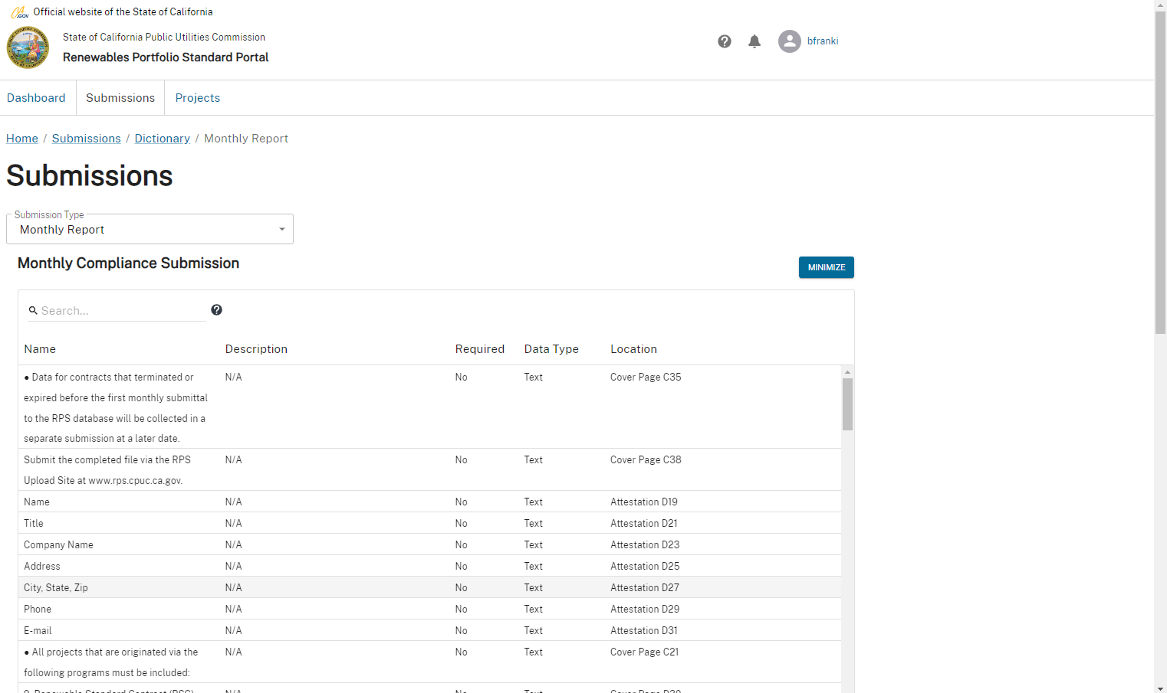

Figure 51: Submissions Displayed from the Data Dictionary Function

### Submission Types

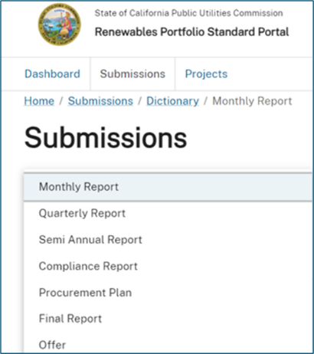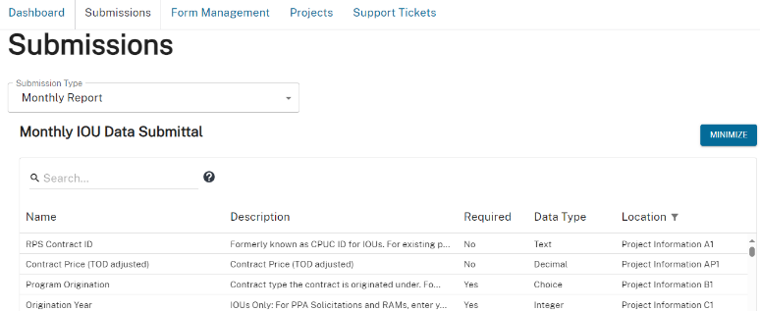Submissions in the Data Dictionary are organized by **Submission Type**. You can change the view to show information for available Submission Types such as **Quarterly Report**, **Semi-Annual Report**, **Compliance Report**, or **Procurement Plan**. Click the Submission Type drop-down, then select the title of the Submission Type you want to view.

Figure 52: Selecting a Submission Type

**Submissions** involve multiple steps of uploading data files, correcting any data validation errors, reviewing the uploaded data, providing confidentiality information, and attesting the data. **Tasks** allow the work to be shared depending on user roles. You can request another user to review and attest the data to complete the submission process after uploading data files, clearing any errors, and providing confidentiality information.

### Sort and Filter

Specific information for your selectedSubmission Type - **Name**, **Description**, **Required**, **Data Type**, and **Location** – is displayed on this page. The Location column shows worksheet names followed by their data item cell address. You can manipulate displayed data by hovering your mouse pointer over the Location column name to reveal two additional controls: **Sort**  and **Filter** .

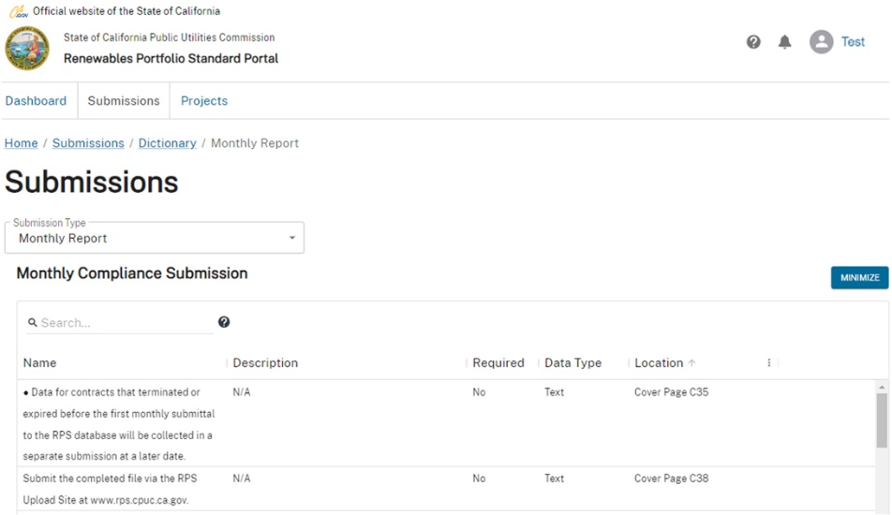

Figure 53: Accessing the Sort and the Filter Functions

Click the Filter  control to open the **Filter** options drop-down as shown below. Click  Filter to open the **Filter** options shown in Figure 55.

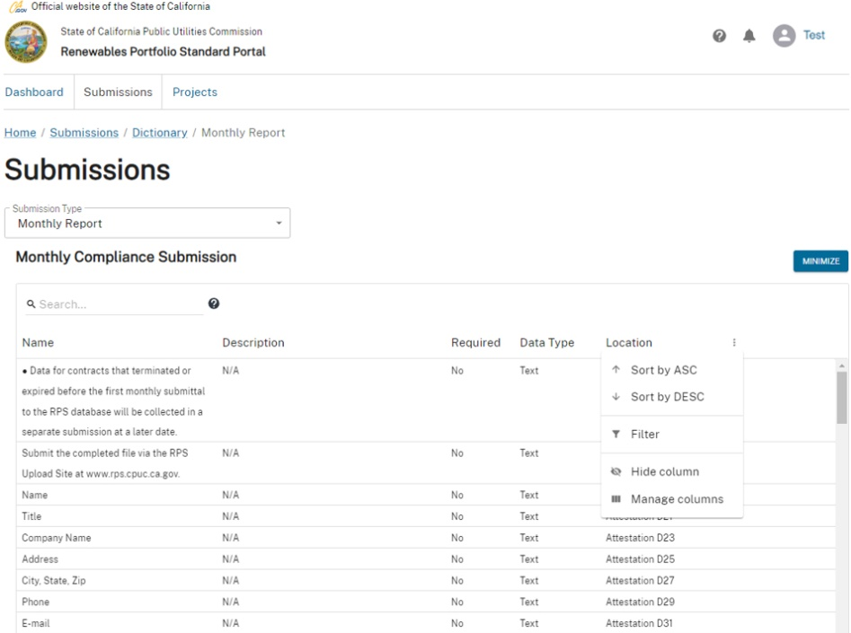

➊

➋

Figure 54: Location Data View Options

Click on Operator to reveal search options for filtering the data.

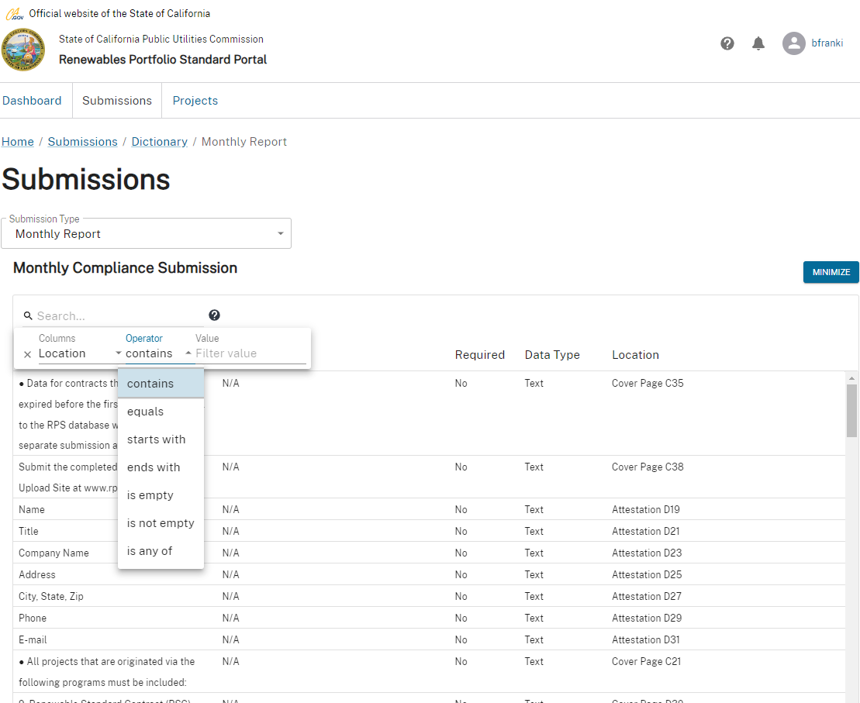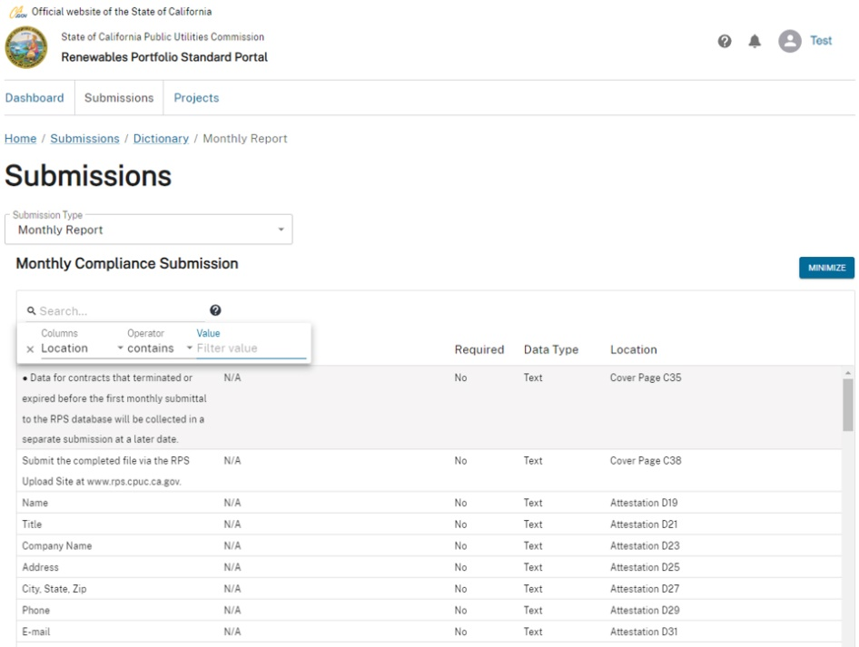

Figure 55: Filter Options

### Search

Use the **Search** function to query the Database for specific information. Click in the  Search… field, enter terms or keys words you want to search for, and press Enter on your keyboard.

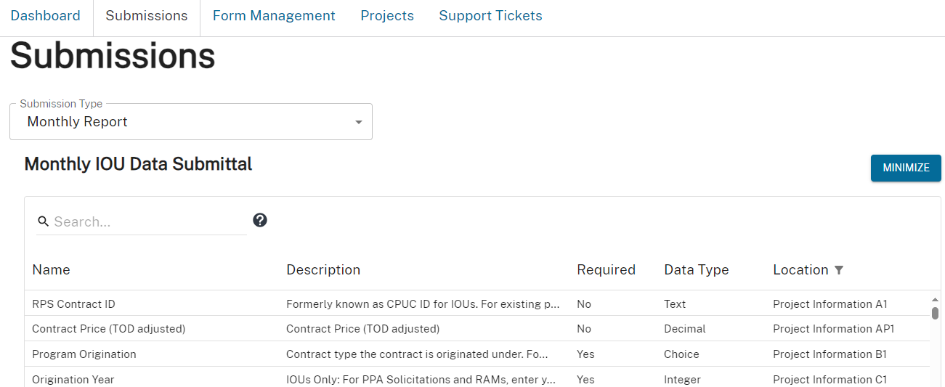

Figure 56: The Search Field

This will show the data items in the Project Information worksheet. This is the main data entry worksheet in the CPUC template file.

When a listed item is selected, a side bar opens that provides more detail on the data item. The information includes a detailed **Description** and allowed values. The detailed description may also provide submission instructions for that data field as shown below.

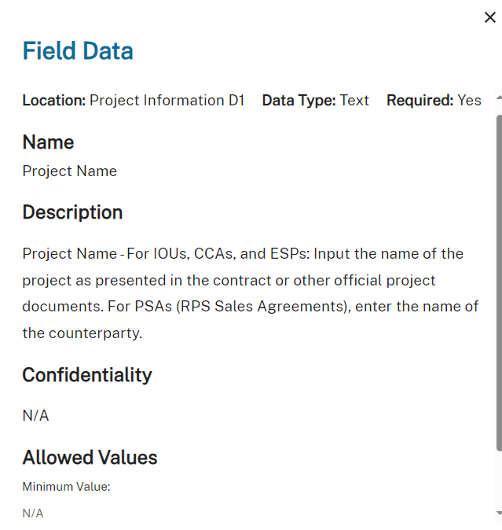

Figure 57: Typical Report Data

## General Help & FAQ

Click the Help  button, then General Help to access RPS Database contacts and frequently asked questions and answers.

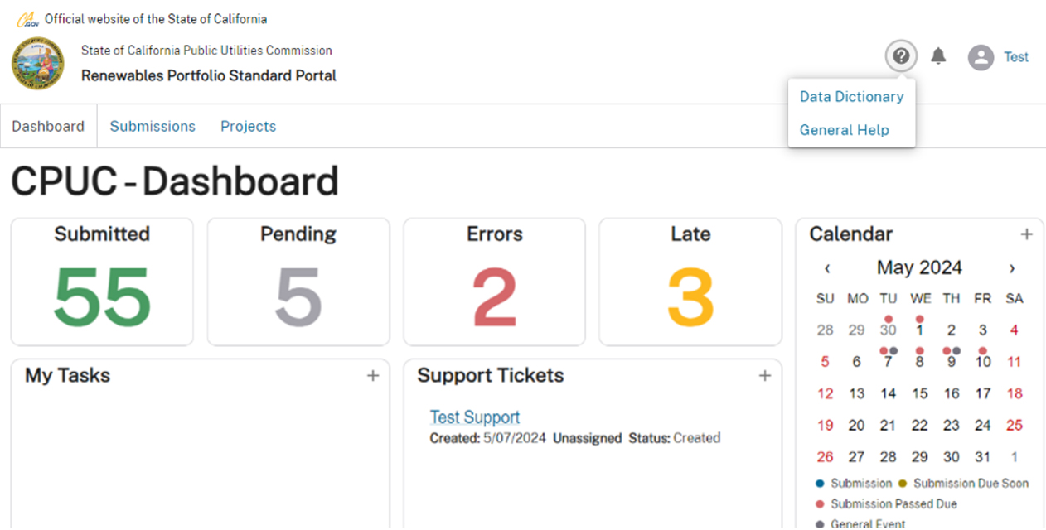

➋

➊

Figure 58: Accessing General Help

Click a  button next to a question to display the answer.

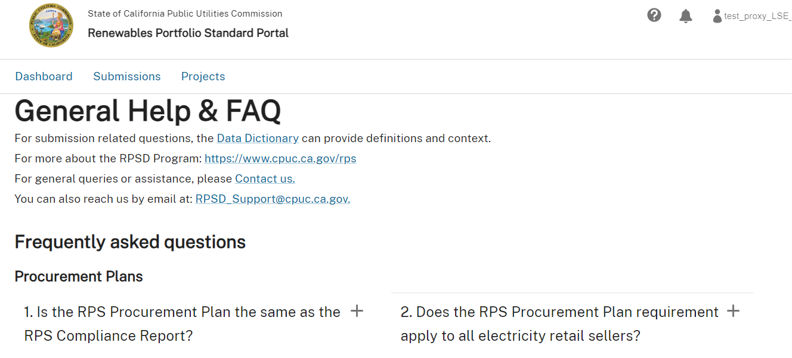

Figure 59: Accessing Answers to FAQs

A sample FAQ for **Semi-Annual PCIA Reports** is shown below.

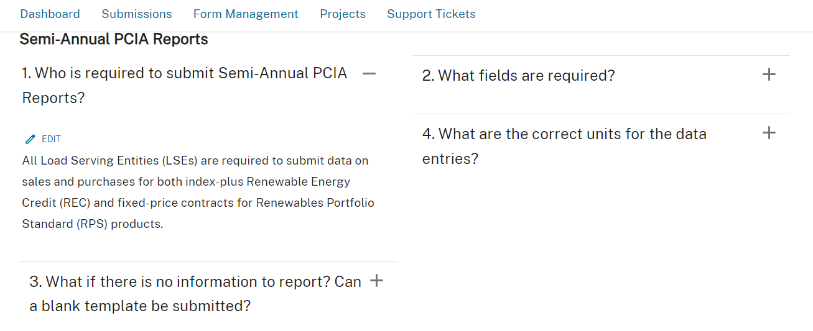

Figure 60: Sample FAQ Detail

## Creating a New Data Submission

Retail sellers need to upload downloaded Excel **Templates** with data to create a new data **Submission**.

Procedure: Creating a New Data Submission

1. Select the Submissions tab, click the + New button, then click Create Submission.

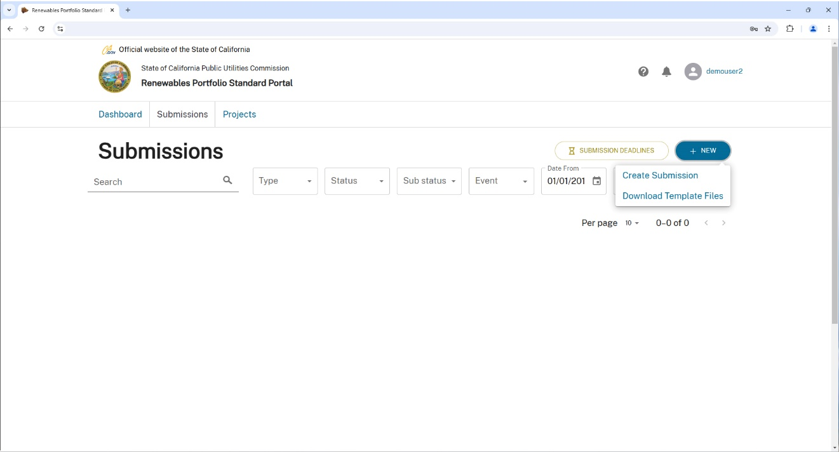

➌

➊

➋

Figure 61: Main Submissions Screen – Download Template Files

Click in the Submission Event field to drop down and select from the available **Events**.

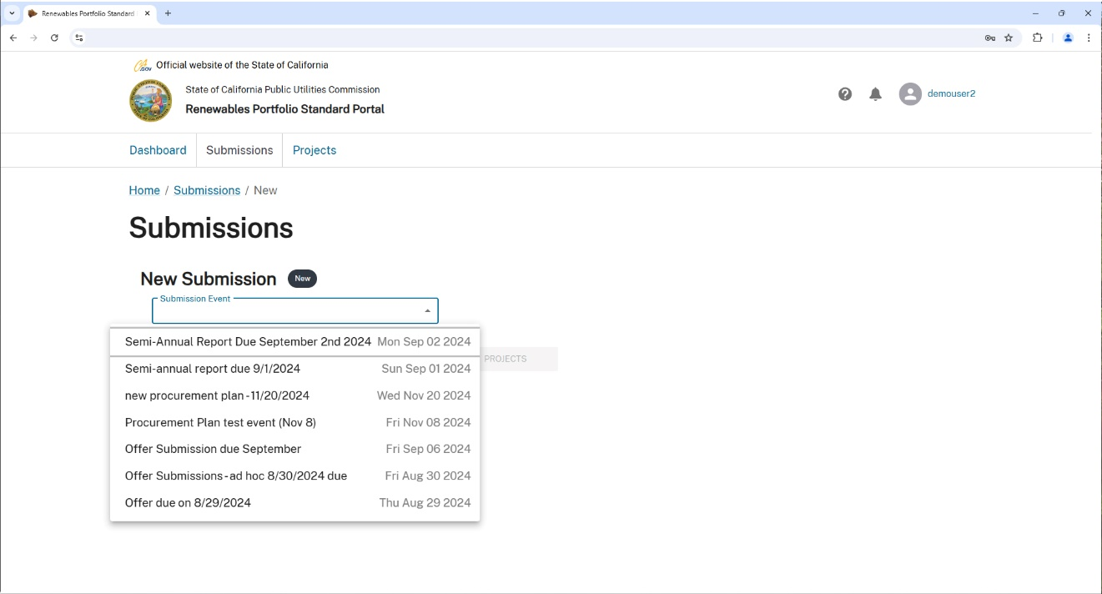

➊

➋

Figure 62: Selecting a New Submission Event

1. Select the WORKBOOKS button.

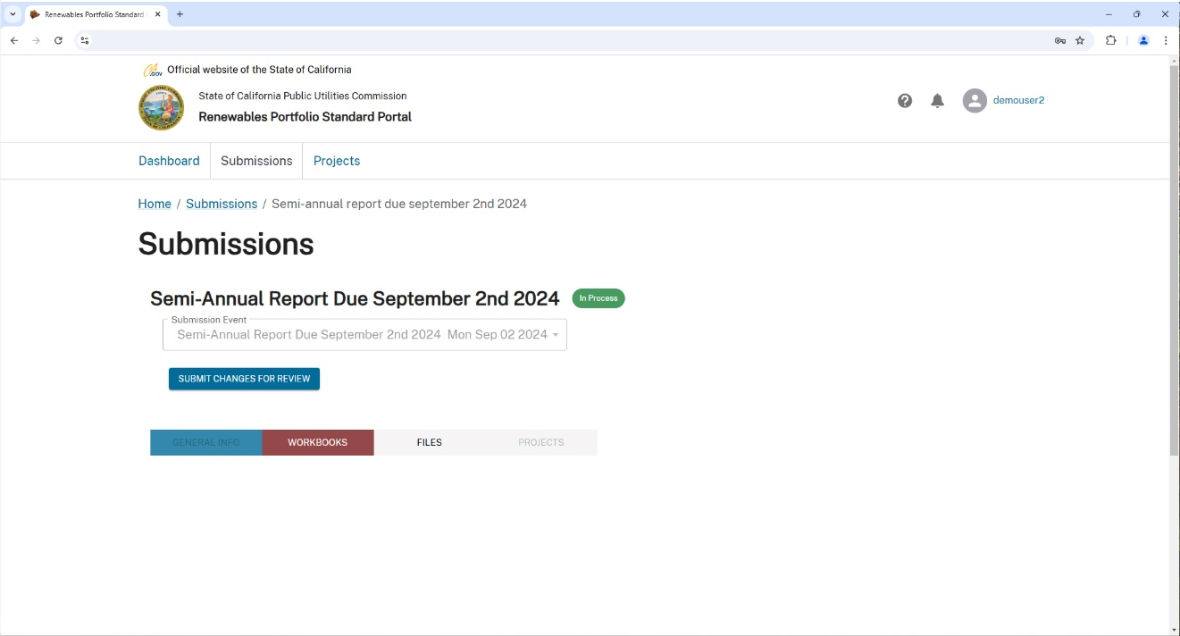

Figure 63: Select a New Submission WORKBOOK

Click the UPLOAD button on the file type you need to upload for this **Submission**.

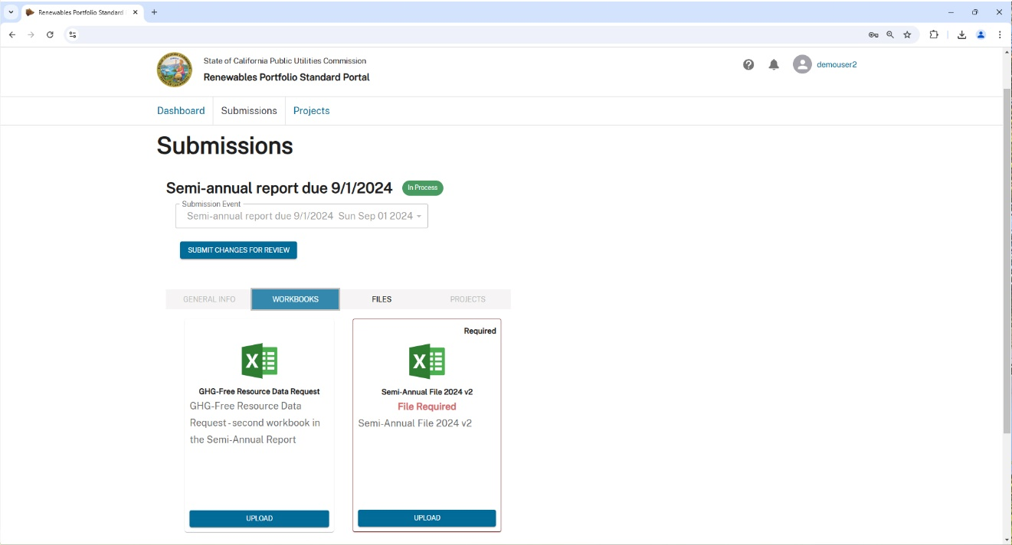

Figure 64: Selecting a New Submission File Type for UPLOAD

Note: You may need to scroll down in this window to access the UPLOAD button or view additional file types.

You now have the option to DOWNLOAD BLANK TEMPLATE or UPLOAD FILE. Click DOWNLOAD BLANK TEMPLATE.

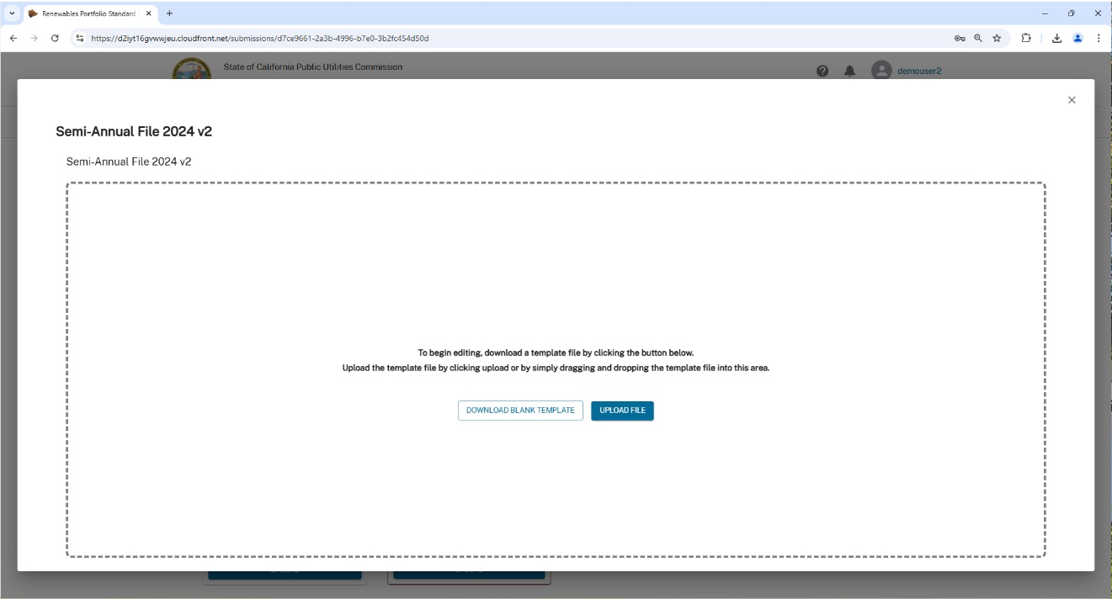

Figure 65: Selecting Template Files by Submission Event

Open the downloaded **Template**, enter your data, and save the file when completed.

Note: you generally need to click the Enable Editing button to proceed with your data entry activities.

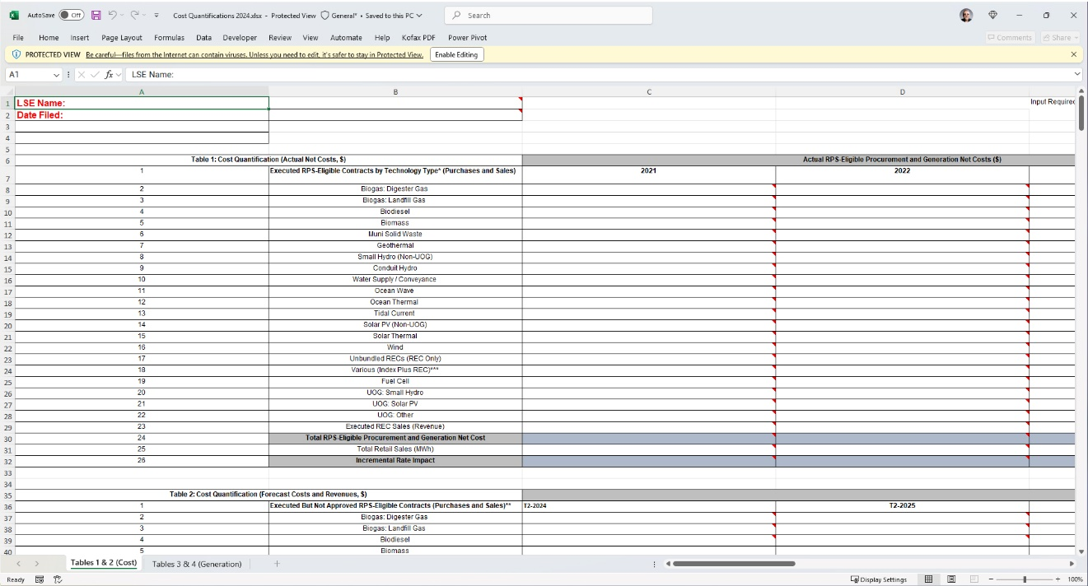

Figure 66: DOWNLOAD a Template File

Navigate to the **Submissions Upload** window and click the UPLOAD FILE button.



Figure 67: Selecting Template Files by Submission Event

Note: after editing the template, if necessary, upload your file by repeating the steps in Creating a New .

The system will upload your updated **Template** file.

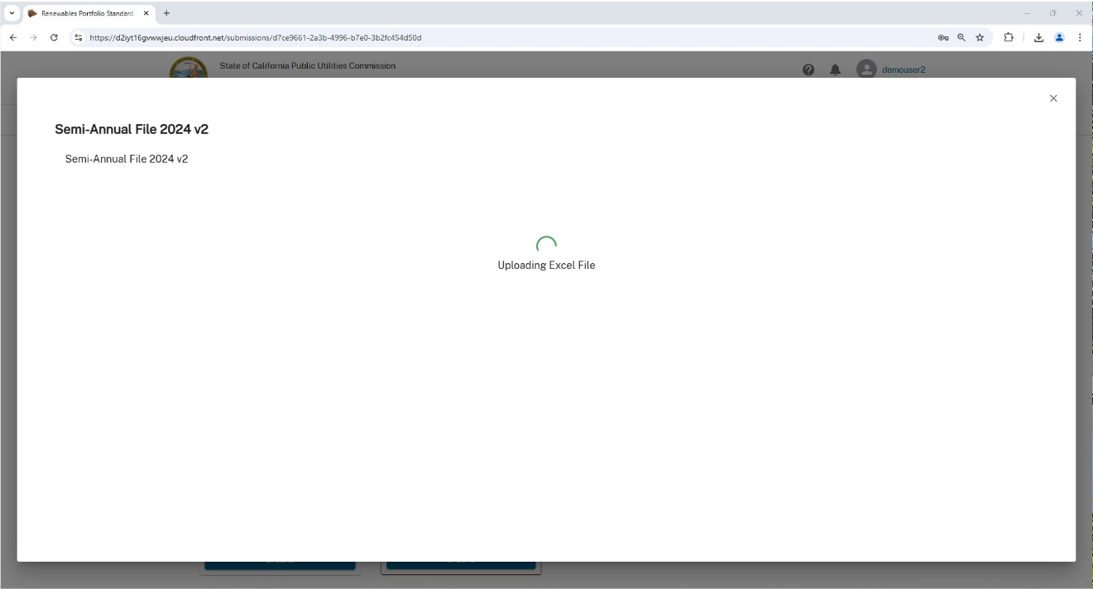

Figure 68: Database Uploading a Submissions File

When completed, the database returns to the previous Submission Upload window. Click the X to exit.



Figure 69: Exiting the Upload Template Window

Click the SUBMIT CHANGES FOR REVIEW button to complete the **Submission** process.



Figure 70: SUBMIT CHANGES FOR REVIEW Window

When completed, the database view is updated to include the REJECT SUBMISSION and ATTEST TO SUBMISSION.

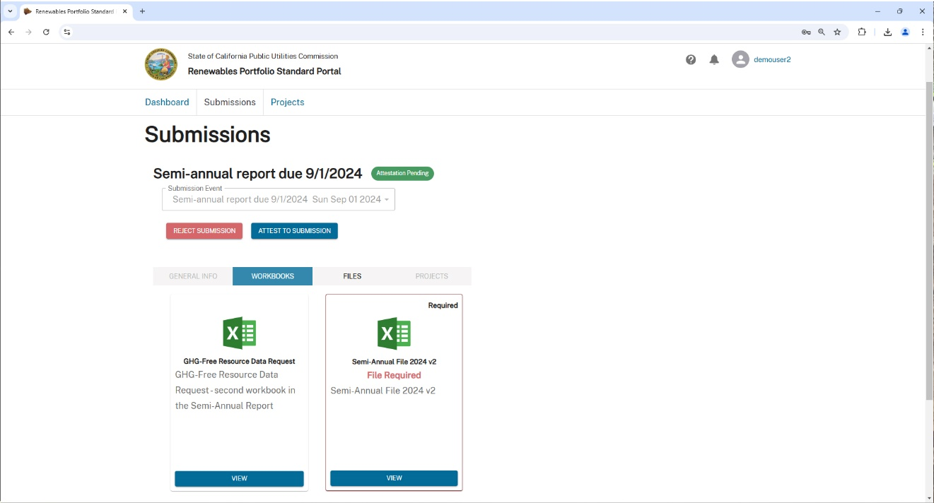

Figure 71: Upload Template Complete

Note: you only see the **REJECT SUBMISSION** and **ATTEST TO SUBMISSION** buttons if assigned the **Attestor** or **Admin** roles.

## Error Handling in Data Submissions

Procedure: Data File Error Correction

1. When an uploaded file is evaluated against the **Submission** type defined data validation rules, data errors will be identified and reported in an **Error** file. Click on it to access, review, and correct the errors.

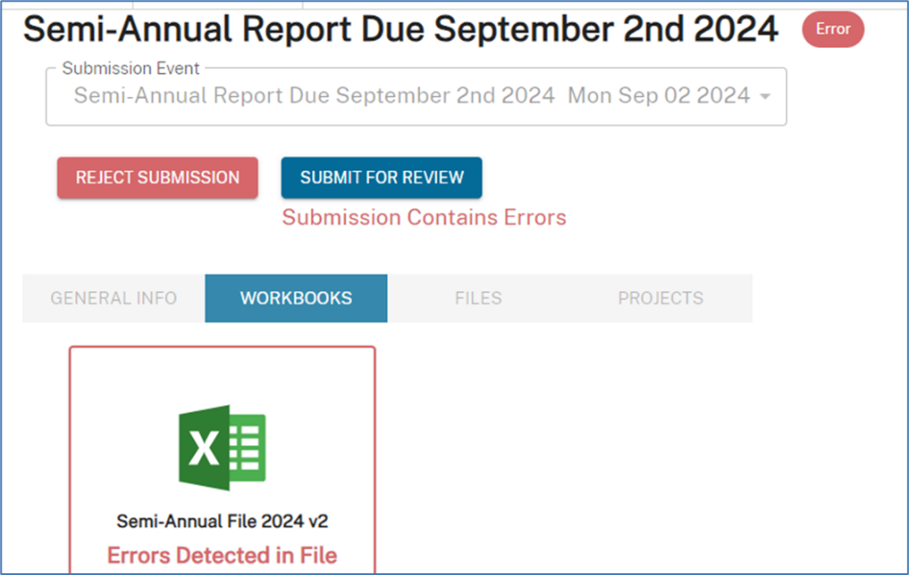

Figure 72: Error Detected in File Window

The **Error** file specifies the name of the Excel worksheet, the cell (row and column) where the data error was found, and the description of the error. Click DOWNLOAD ERROR FILE to download and edit the file on your computer.

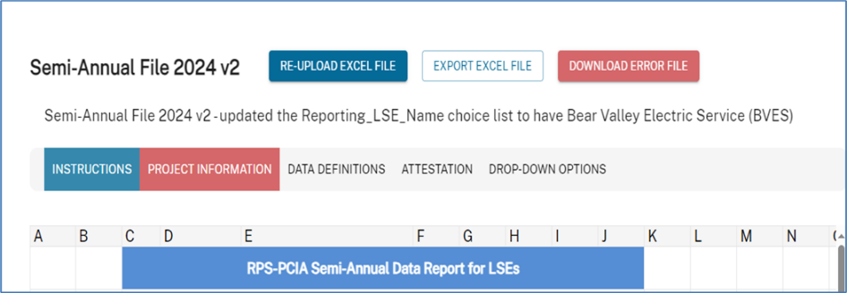

Figure 73: DOWNLOAD ERROR FILE Window

When you are finished making corrections to the Excel **Error** file, click the RE-UPLOADEXCEL FILE to resubmit the file to the database for processing.



Figure 74: RE-UPLOAD EXCEL FILE Window

## Submission Queries

Queries can be performed on previous Submissions by searching with key words. You have access to your organization’s historical Submissions and can download historical files.

You can also query your organization’s RPS projects and explore documents including **Contracts** and **Shapefiles**. This is covered in the next section.

To search previous Submissions, click on the **Submissions** tab at the top left of the page. Then click in the Search field, type in the key words you want to search for in the historical Submissions. Press Enter on your keyboard to initiate the search.

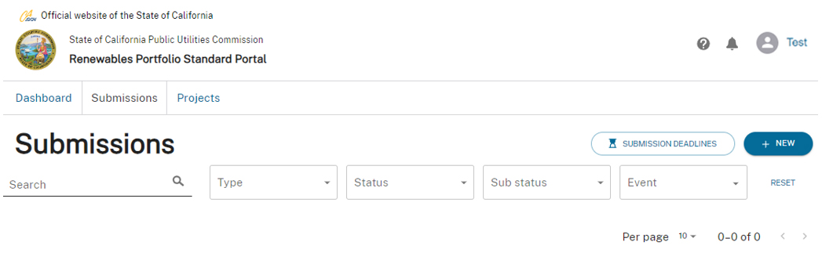

➋

➊

Figure 75: Submission Query Window

# Projects Functionality

## Project Search

Clicking the **Projects** tab launches a default search, that is, all Organizational **Projects** are displayed. There are multiple filters available to help you locate a specific **Project**.

This window features a combination of fill-in fields and drop-downs allowing you to provide very specific search parameters. When you have located the Project you are looking for, for example, Wind Resource II, click it to proceed to the Project Details view (Figure 77).

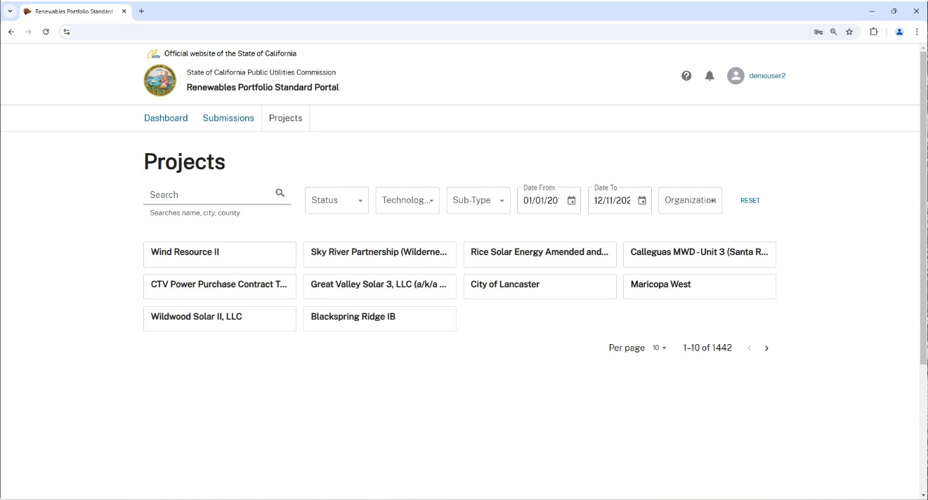

➊

➋

➌

➍

➎

➏

➐

➑

➒

Figure 76: The Projects Main Window

1. Search – a text field to enter Organizational attributes to search:

* Name
* City
* County

1. Status – click and drop down to select from the various **Project** statuses:

* All
* Executed
* Negotiation
* Online
* Expired
* Terminated

Technology – these options are available from the Technology drop-down menu:

* All
* Biodiesel
* Biogas
* Biomass
* Conduit hydro
* Digester gas
* Geothermal
* Hybrid
* Landfill gas
* Muni solid waste
* Ocean/tidal
* Small hydro
* Solar PV – Rooftop
* Solar PV – Ground mount
* Solar Thermal – No storage
* Solar Thermal – With storage (molten salt)
* Space solar
* Wind
* Various

1. Sub-Type – choices are:

* All
* N/A

1. Date From – Date To – choose a date range to search for a **Project**:

* You can either enter dates manually from your keyboard or click on the calendar  icon and select a date.

1. Organization – you will only see your Organization in this drop-down.

Note: Users with Admin rights across more than one Organization may see multiple selections here.

1. Reset - resets the query **Filter** values (except the Search field).
2. Per page - choose to view up to 50 **Projects** by dropping down the Per page selector Projects that result from the query are displayed in a clickable card format.
3. < > - scrolls through **Project** search result pages.

## Working with Projects

The individual **Project** view displays **Project** specific information. The page is divided into **Project Details** providing detailed data about the **Project**, and geographic **Location Data** for any Power Plant(s), filterable by Energy Source, associated with the **Project**.

**Project Data** is uploaded to the database via a Shape File data template file.

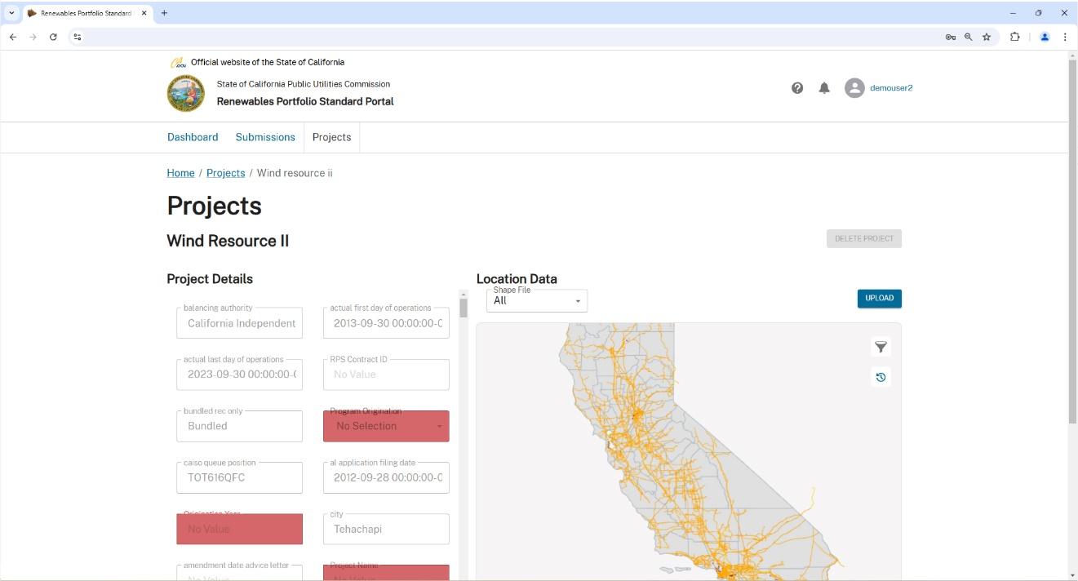

Figure 77: The Project Details Window

Any items in the **Project Details** area that are highlighted in red are missing and need to be provided via a **Shapefile** UPLOAD.

To interact with the **Location Data** view, hover over the map area and use mouse commands to manipulate the map position and magnification:

* **Left click+drag** – moves the entire image up/down/left/right.
* **Wheel** – zoom in/zoom out.
* **Right click+drag** – rotates the image clockwise/counter-clockwise/rearward/forward.
*  - opens filter parameters of:
  + Energy Source
  + Select Power Plant
*  - resets the **Location Data** map to its default display view.

Procedure: Uploading a Project Shape File

1. Click the UPLOAD button.



Figure 78: UPLOAD a Shape File

Click SELECT A FILE TO UPLOAD and use your computer’s file browser to locate and select a **Shape File**.

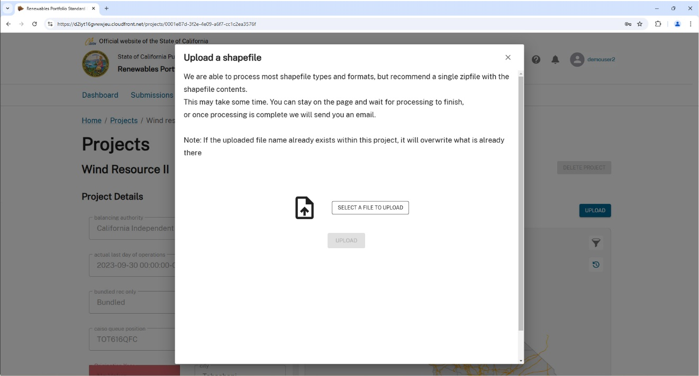

Figure 79: The Shape File Upload Window

Click UPLOAD to send your **Shape File** up to the database for processing.

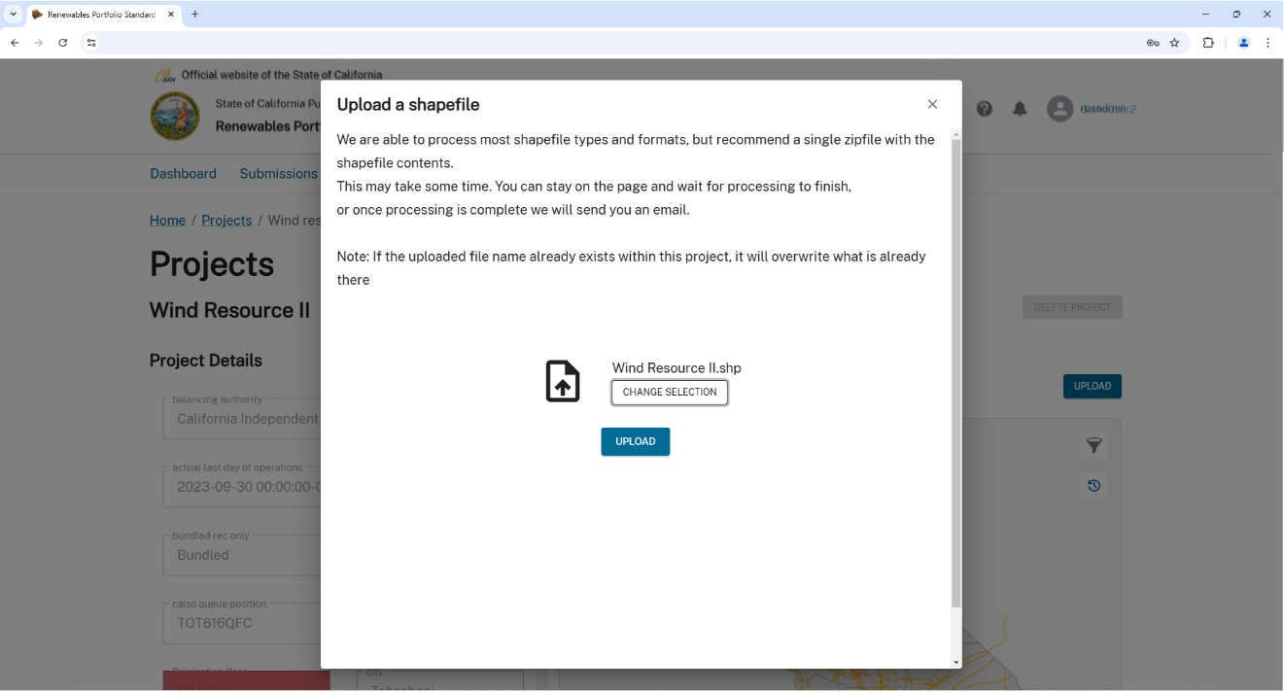

Figure 80: Shape File Selected

Note: you can upload a different file by clicking the CHANGE SELECTION button to locate and select another file.

Stand by while the **Shape File** is processed by the database. The progress is displayed in the window.

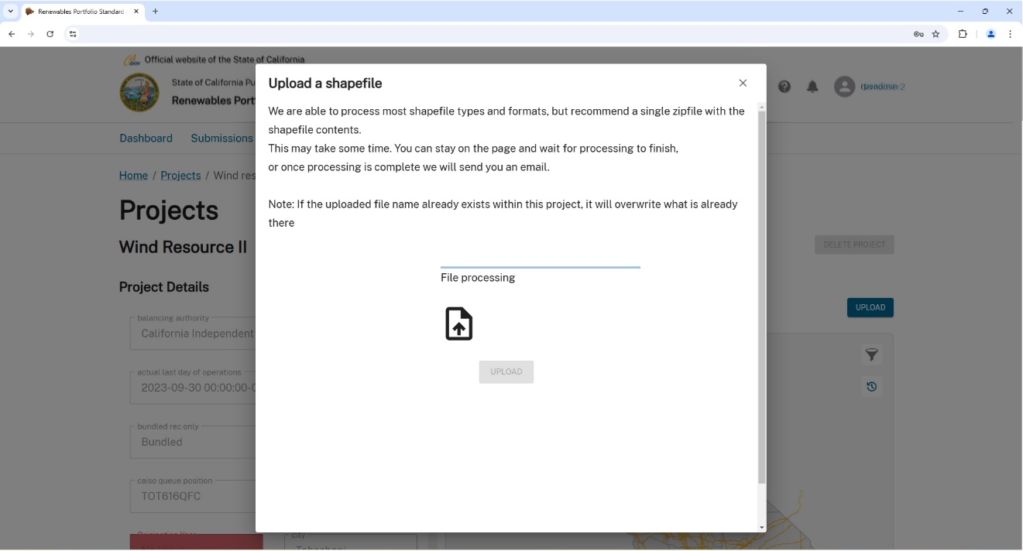

Figure 81: Shape File Processing

Note: if there is any issue encountered during **Shape File** processing, you will receive a **file processing failed** error message. You must edit the **Shape File** to correct the issue(s) or select and upload an alternate **Shape File**.

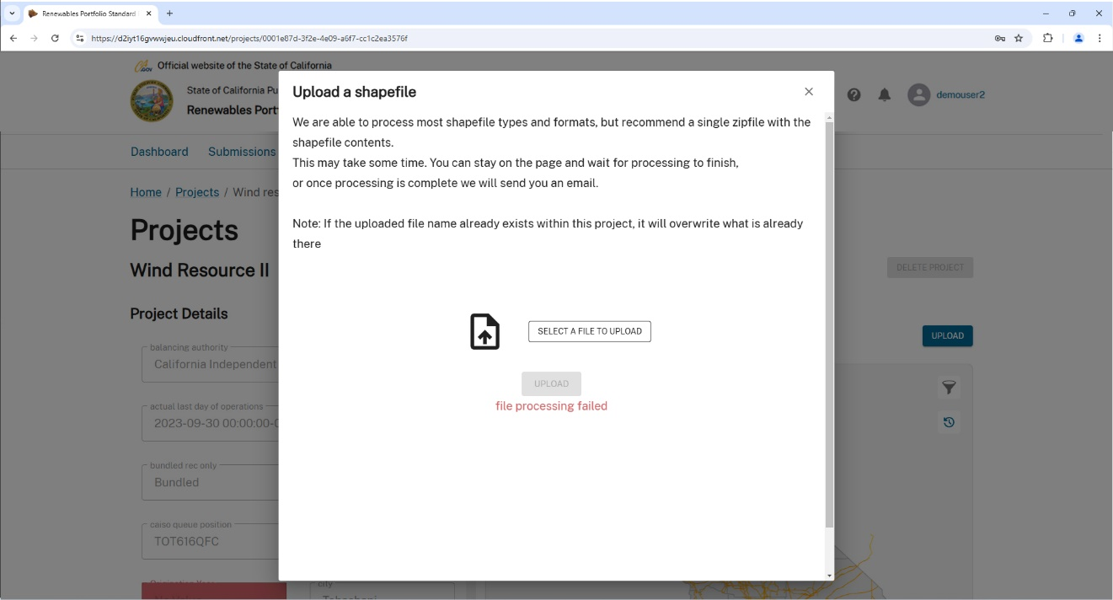

Figure 82: Shape File Processing Failed Error Message